

| **North Carolina Agricultural & Technical State University** |
| --- |

**Senior Design for Electrical & Computer Engineers**

**Spring 2023**

**ECEN 478 Progress Report II: Plant Growth System**

**(EZGrow)**

**Group 7: William Kelly, Nana Hutchison Brandon Stephens, Alexis Plasencia Leos**

**Administered by: Dr. Ali Abdul-Fadl**

**Faculty Advisor: Dr. Kelly**

**Table of Contents:**

**Cover Page: …………………………………………… 1**

**Table of Contents: …………………………………….. 2-3**

**Abstract: ……………………………….……………… 4**

**Introduction: ………………………………………….. 5**

**List of Tables and Figures: ………………………….. 7**

**Group Roles:** **…………………………………………**.. **8**

**Research: ……………………………………………… 9-14**

**Constraints: …………………………………………… 15**

**Block Diagrams: ……………………………………….. 16-17**

**Code Flowchart: ……………………………………….. 18**

**Tentative Schedule: …………………………………….. 19**

**Testing: ………………………………………………….. 20-25**

**Final Results: ……………………………………………20-27**

**Conclusion: ……………………………………………… 28**

**References: ……………………………………………... 30**

**Appendices - Decision Matrices:………………………. 31**

**Appendices - Alternative Designs:................................... 32-34**

**Appendices - Experimental Pictures:............................. 35-36**

**Appendices - Source Code: ............................................ 37-43**

**Appendices - Meeting Summaries: …………………….. 44-45**

**Appendices - Parts List: ………………………………… 45-49**

**Abstract:**

Through the development of our project, we will explore creative new options for crop production on a personal scale by using (implementing a method that uses less land and less work) sustainable methods, while also conserving space through the use of a terrarium. Terrariums are enclosed areas specifically designed to provide a stable environment for plants and animals; a definition that is broad in the sense that they can serve personal or scientific observational purposes. In this case, we will be testing the implementation of an automated indoor terrarium that grows crops free of human interaction. Through the use of microcontrollers and embedded systems, we plan on integrating multiple sensors paired with the appropriate actuators to maintain sustainable environmental conditions for a specific herb.

**Introduction:**

By the year 2050, there will be an expected two billion more people on Earth than there are today. Modern agricultural growth and production cannot keep up with the demand to supply such a need. Through the development of our project, we will explore new creative options for crop production on a personal scale by using more sustainable methods, also conserving space through the use of a terrarium. Terrariums are enclosed areas specifically designed to provide a stable environment for plants and animals; broad in the sense that they can serve personal or scientific observational purposes. In this case, we will be testing the implementation of an automated indoor terrarium that grows crops autonomously, free of human intervention. Through the use of microcontrollers and embedded systems, we plan on integrating multiple sensors paired with the appropriate actuators to maintain sustainable environmental conditions for a specific plant. This includes system integration for temperature control, humidity, watering, and lighting. As the trend of individuals gardening and growing their healthy foods grows as the price of organic produce increases, our design will provide an alternative solution to achieving a healthy lifestyle for those whose living conditions may not allow them the space or provide adequate conditions to sustain plant life. After doing some research there are a few similar products on the market; *the Gardyn Homekit 2.0*, *the Click & Grow Smart Garden,* and *the AeroGarden Harvest Elite*. The Gardyn Homekit 2.0 is listed at $750 USD, and allows for users to grow full-sized crops (4-5 feet), is not enclosed, includes automatic watering, grow lights, wifi connection, and cameras, and is powered. The Click and Grow Smart Garden is listed at $229 USD, grows smaller crops (>1ft), is not enclosed and includes automatic watering. The AeroGarden Harvest Elite is listed at $219 dollars, grows smaller crops (<2 ft), has a hydroponic system, has grow lights, and does not include automatic watering. These products differ from our proposed design in a few ways, though it will be useful to learn from their implementations to help make our design better. Our product, though a prototype, has the ability to do everything its competitors can do (AND more) for half of the price. The distribution of our product will spare individuals the time, land, and money that they would usually need by growing crops in their own homes, saving them the exasperation of constantly monitoring their crops. We started to experiment with the sensors and actuators to see how well they work on their own. Afterward, we recorded their results and compared them to their respective commercial product counterparts. Our goal was to make sure they are working properly so they can be integrated into the system. Once our plans were completed, every actuator was modified so that they can be controlled by the ESP-32 microcontroller. Discussed in this report is how the integration happens.

**List of Tables and Figures:**

Page 8 Table 1: Group Roles

Page 9 Figure 1: Terrarium Example

Page 11 Figure 2: Herb Growth Stages

Page 14 Figure 3: Blink/IoT Diagram

Page 14Figure 4: Existing Design Comparison

Page 19 Table 3: Tentative Schedule

Page 20 Figure 5-7: Enclosure Sketches

Page 22 Figure 8: Capacitive Soil Moisture Sensor

Page 22 Figure 9: DHT 22

Page 22 Figure 10: DS18B20

Page 23 Figure 11: Water Pump

Page 23 Figure 12: Fan

Page 23 Figure 13: Heat Mat

Page 24 Table 4: Humidity Sensor Testing

Page 24 Table 5: Soil Moisture Sensor Testing

Page 25 Figure 14: Serial Monitor Reading

Page 26 Figure 15: IOT Dashboard

Page 26 Figure 16: Enclosure

Page 28 Table 5-8

Page 29 Figure 17-20: Alternative Designs

Page 31 Figure 21: Arduino Setup

Page 31 Figure 22: Relay Construction

Page 32 Figure 23: Soil Moisture Sensor Testing

Page 32 Figure 24: Temperature Sensor Testing

Page 33 Figure 25: PrototypeV2 Construction

Page 33 Figure 26: BJT Solution

Page 40 Table 2: Tentative Parts List

**Group Roles:**

***Table 1***

| **Roles:** | **Members:** |
| --- | --- |
| Terrarium | Alexis / Brandon |
| IoT | Trey |
| Hardware/Sensors | Nana / Alexis / Brandon |
| Coding Hardware/Sensors | Trey / Nana |
| Herb/Plant | Brandon |

**Research:**

**Terrarium**:

The terrarium design will be a key part of our senior design project. “This being said, it is important to choose the best parameters for the terrarium to ensure that the plant inside will have enough space to grow and house all of the necessary sensors” [1]. Along with, having the total weight of the terrarium be less than 75 pounds. Creating the terrarium from scratch is probably the most reliable method to achieve this. However, buying a prebuilt enclosure could still be a great alternative (based on availability and price).

The terrarium will be a rectangular prism constrained by the plant inside. Basils grow about 12 to 14 inches in height and their roots burrow around 8 inches. Taking the highest height into account, the enclosure must at least be 22 inches tall. The optimal size for the terrarium will be 36 x 18 x 24 (inches). “Wood planks or aluminum sheets are sufficient materials to build the housing” [2]. Acrylic sheets will be used for the perimeter so that natural light can shine through. The temperature inside would not get hot enough to affect the sheets. “Terrariums can include removable covers to seal in moisture; therefore, the enclosure will have a lid” [1]. The microcontroller will be outside of the terrarium in its housing along with other amenities connected to it.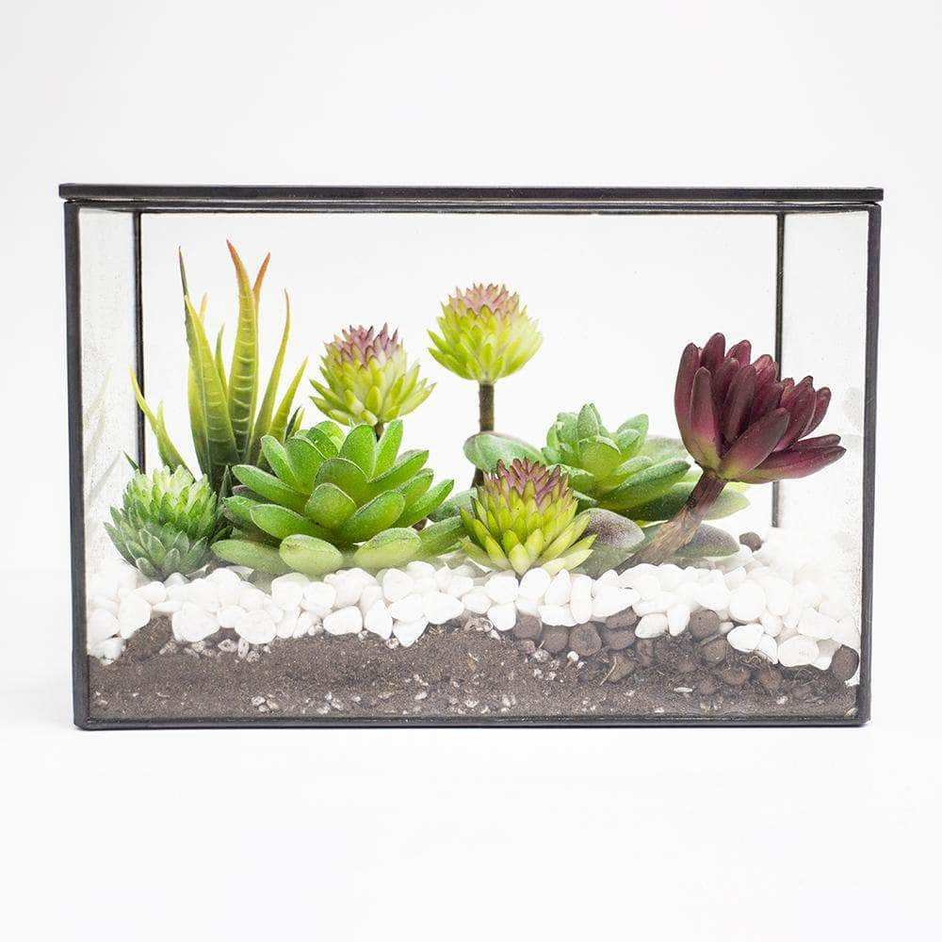

**Figure 1:** *Example of a typical terrarium*

**Herbs**:

The goal of our design project is to create a contained environment that can sustain life and doesn’t require many direct human influences or interactions. The terrarium should be completely self-sustaining using computer and electrical engineering concepts. To create a proper terrarium for experimental purposes, we first must find a good plant and create a good testing environment to ensure our final design’s success.

Different plants and soils are used to test for different purposes such as medical, cosmetic, or even combative research. We need an environment suitable for general farming. A good plant to experiment on should be fast-growing and easy to observe and manipulate. “A couple of commonly known plants fit this criterion such as beans or different breeds of tomatoes. These plants grow fast and progress can easily be observed” (3).

Another option we have is to use herbs for our experiment. They also grow fast, require little maintenance, and also have the added benefit of being cut without damaging the plant. Some good herbs we could use for testing would be basil, mints, or even garden cress. Garden cress is an especially fast-growing plant and is perfect for getting quick results. Lastly, flowers could also be a good plant to experiment on. Specifically, the marigold is a fast-growing plant that if kept at 70 degrees Fahrenheit can grow within five to ten days. “These options of plants for testing don’t need an abundance of resources to grow which makes them great for experiments to find the errors within our terrarium” (3).

It seems that the best plant to experiment with would be Basil (Ocimum basilicum), which is a common culinary herb of the family Lamiaceae (Mint). We chose this plant due to it being a common culinary plant and its usefulness for quick results. On average, basil takes seven to ten days to grow and is a relatively small plant. Basil can grow up to 24 inches in height. It is recommended that soil is relatively warm, around 70 degrees Fahrenheit during the day and 50 degrees Fahrenheit during the night when growing basil because this plant is grown during the summertime. Basil also needs six to eight hours of sunlight even though partial light is okay too but not recommended. The soil for which the herb is grown should be moderately fertilized and moist. The pH of the soil should be around 6 to 7.5 in acidity. Also, the humidity levels should be between 40 to 60 percent. When planting basil it should be sowed no deeper than a quarter inch deep and 10 to 12 inches apart from each other. “Basil is ready to be harvested when it has grown 6 to 8 inches tall” (4).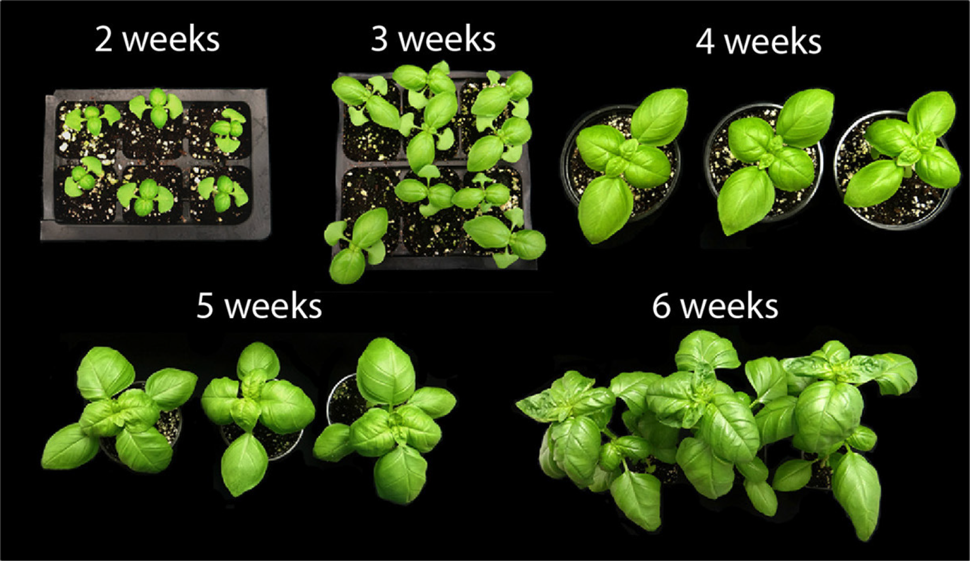

***Figure 2:*** *Example of the growth cycle of Basil*

**Sensor Types**:

**Temperature sensor:** DS18B20

The DS18B20 is a **low voltage, precision centigrade temperature sensor**. It provides a voltage output that is linearly proportional to the Celsius temperature.

**Soil Temperature Sensor: (DS18B20)**

**Humidity sensor:** DHT22, DHT20

The DHT22 is a basic, low-cost digital temperature and humidity sensor. It uses a capacitive humidity sensor and a thermistor to measure the surrounding air and spits out a digital signal on the data pin (no analog input pins needed).

**Illumination sensor -** (Available LDRs from Professor Ali)

**LPL Battery -** Lithium Ion Battery (Available from Professor Ali)

**Soil moisture sensor -** ALMOCN capacitive soil moisture sensor

# Capacitive Soil Moisture Sensor Module Corrosion Resistant Soil Humidity Detection Module for Arduino Moisture Detection.

The DS18B20 temperature sensor will monitor the internal temperature and tell the microcontroller to cut the heat lamp and/or heat pad breaker on or off based on the set high and low temperatures. “The DHT22 sensor will monitor the humidity and control the breaker to a humidifier/ fogger to maintain a humidity level above a set level” (6). Lastly, the ALMOCN soil moisture sensor will tell its microcontroller when the soil moisture is too dry and will trigger the breaker to actuate a pump that will draw water from the reservoir through the sprinkler system. The capacitive sensors are resistant to corrosion. All of these sensors shall also be in some way connected to a single microcontroller, allowing the user to monitor all environmental measurements on a supported electronic device via IoT.

**IOT/BLYNK:**

Internet of things (IoT) technology is a system of complementary computing devices, digital machines, objects, animals, or people that can be provided with unique identifiers (UIDs) to transfer data over a network without requiring human-to-human/human-to-computer interaction. “The “Thing” in the internet of things refers to a manmade OR natural object (Ex: a person with a heart monitor implant, or an automobile with built-in sensors) that can be assigned an IP address and can transfer data over a network” [8]. An internet of things environment consists of web-enabled smart devices that use embedded systems to collect, send, and act on data they acquire from their environments. IoT is important because it allows people to automate processes, cut down on waste, and reduce the labor necessary.

BLYNK is an IoT platform used to connect devices to the cloud and build mobile apps to remotely control and monitor those devices. “BLYNK has the ability to control hardware remotely, display and store sensor data, as well as visualize data. There are three major components to the BLYNK platform: The BLYNK app (allows you to create User Interfaces for your projects), the BLYNK server (handles all communications between smartphone and hardware, and the BLYNK libraries (enable communication with the server and process incoming/outcoming commands)” [9].

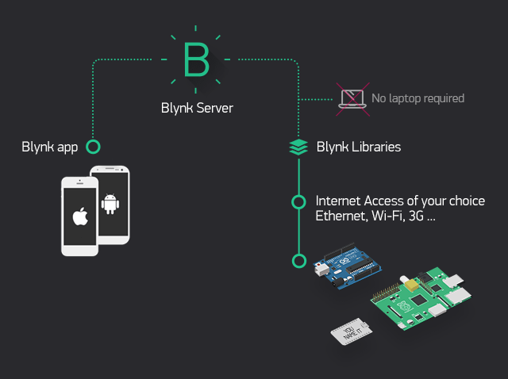

***Figure 3:*** *Shows the functionality of the BLYNK Internet of Things Interface*

**Existing Designs:** 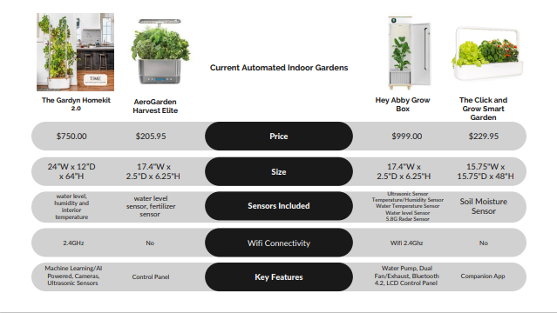

***Figure 4:*** *Shows a comparison of similar designs on the market*

**Constraints:**

**Engineering Requirements:**

* Soil Temperature must be between 50°F and 70°F for germination
* Soil Moisture Content must be one inch of water per week
* Illumination must be between 6 to 8 hours of sunlight per day
* Air temperature must be between 50 and 80°F
* Humidity must be between 40 and 60%
* Must accept standard North American 120 AC power.
* Must have wifi connectivity
* Must have a user interface via phone
* Battery Backup
* Must water plants autonomously

**Marketing Requirements:**

* Must weigh less than 75lbs
* System should never get hotter than 90 or colder than 50
* Parts cost under $250
* Must be no bigger than 36 x 18 x 24 (ideally 24 x 18 x 24)

**Plant Requirements:**

* Soil temp: Daytime temperature - 70 degrees, Night Time-temperature - 50 degrees
* Basil max height is 12 to 24 inches
* Humidity levels should be between 40 and 60 percent
* Herb should be sowed a quarter inch deep and 10 to 12 inches apart from each other
* Growth rate is 7 to 10 days
* Soil should be moist and fertilized with a pH level of 6 to 7.5 acidity
* Basil herb should have 6 to 8 hours of sunlight

**Block Diagrams:**

**Level 0:**

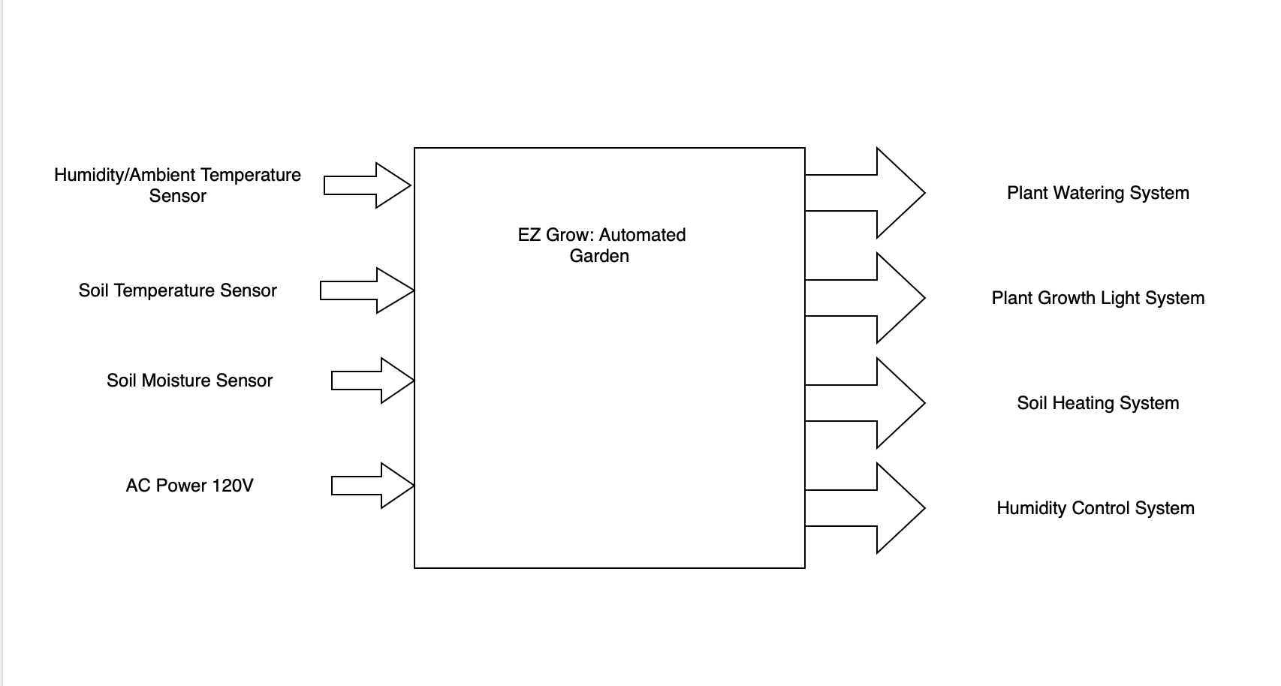

**Description:**

The Plant Growth System will consist of the terrarium that houses the plant, as well as the microcontroller that receives information from the sensors and commands the output systems.

* The soil moisture sensor will be directly connected to the Watering System
* The humidity/temperature sensor will be connected to the Humidity Control System
* The soil temperature sensor will be connected to the Soil Heating System
* The power voltage will provide power to all these components.

**Level 1:**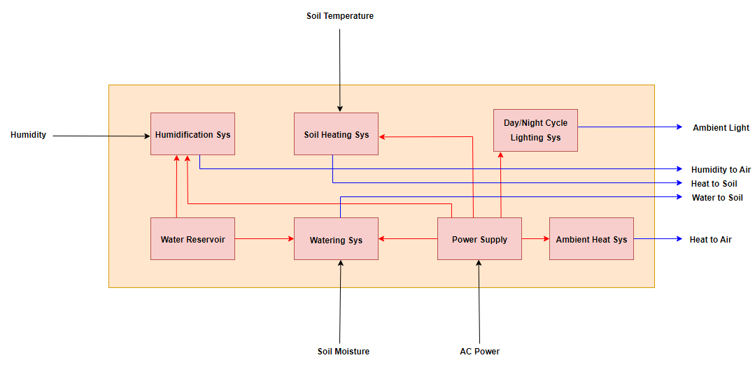

**Level 2:**

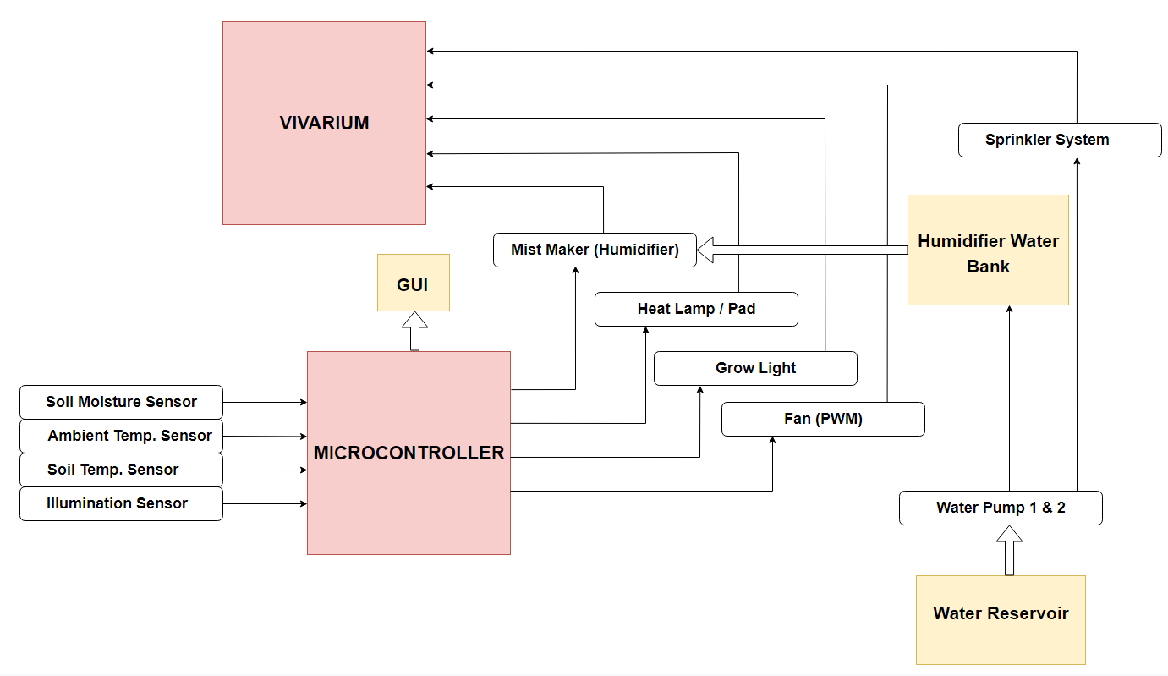

***Figure 7: Level 2 Block Diagram***

**Code Flowchart:**

**Flowchart:**

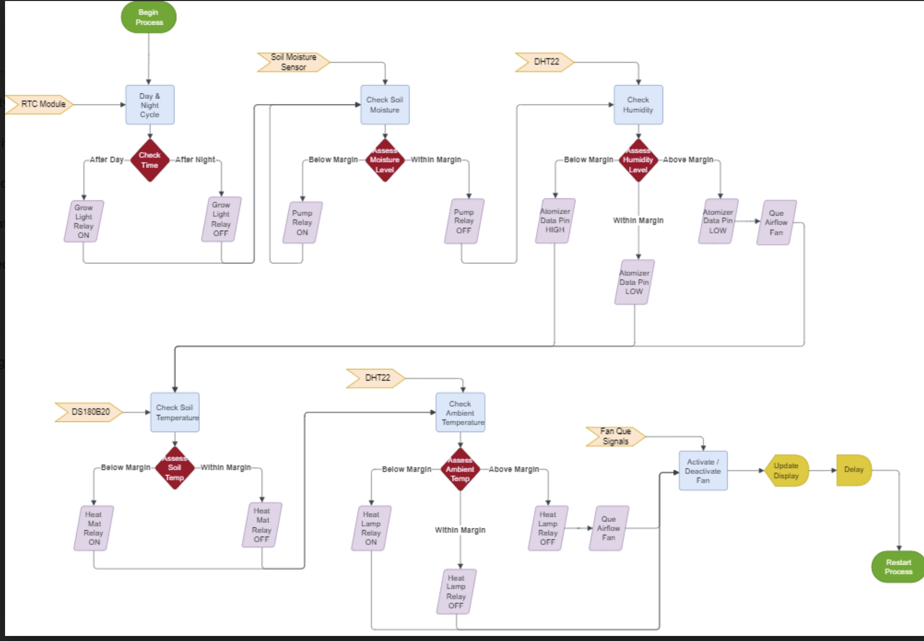

**Description:**

This flowchart illustrates how each module in our code will need to function. It is a good visual representation to reference when coding and deciding what needs to be done.

**Tentative Schedule:**

***Table 3:*** *Describes the tentative schedule for the project.*

| **Dates:** | **Action:** |
| --- | --- |
| November 6th - November 16, 2022 | Order Parts |
| November 20th - December 13th, 2022 | Work on Individual Components *Temperature Sensor  *Water Pump  *Terrarium Shell  *IOT/BLYNK Connectivity  *Fan  *Backup Battery/Power Connection  *Heating Mat |
| January 12 - February 11, 2023 | Create a Working Prototype |
| February 12 - February 26, 2023 | Testing Phase 1 |
| Feburary 27 - March 13, 2023 | Revision Phase 1 |
| March 14 - March 28, 2023 | Testing Phase 2 |
| March 29 - April 11, 2023 | Final Revisions |
| April 12 - May 1, 2023 | Documentation / Final Touches |
| Exposition May1 | Present |

**Testing:**

**Enclosure:**

**Sketches:** 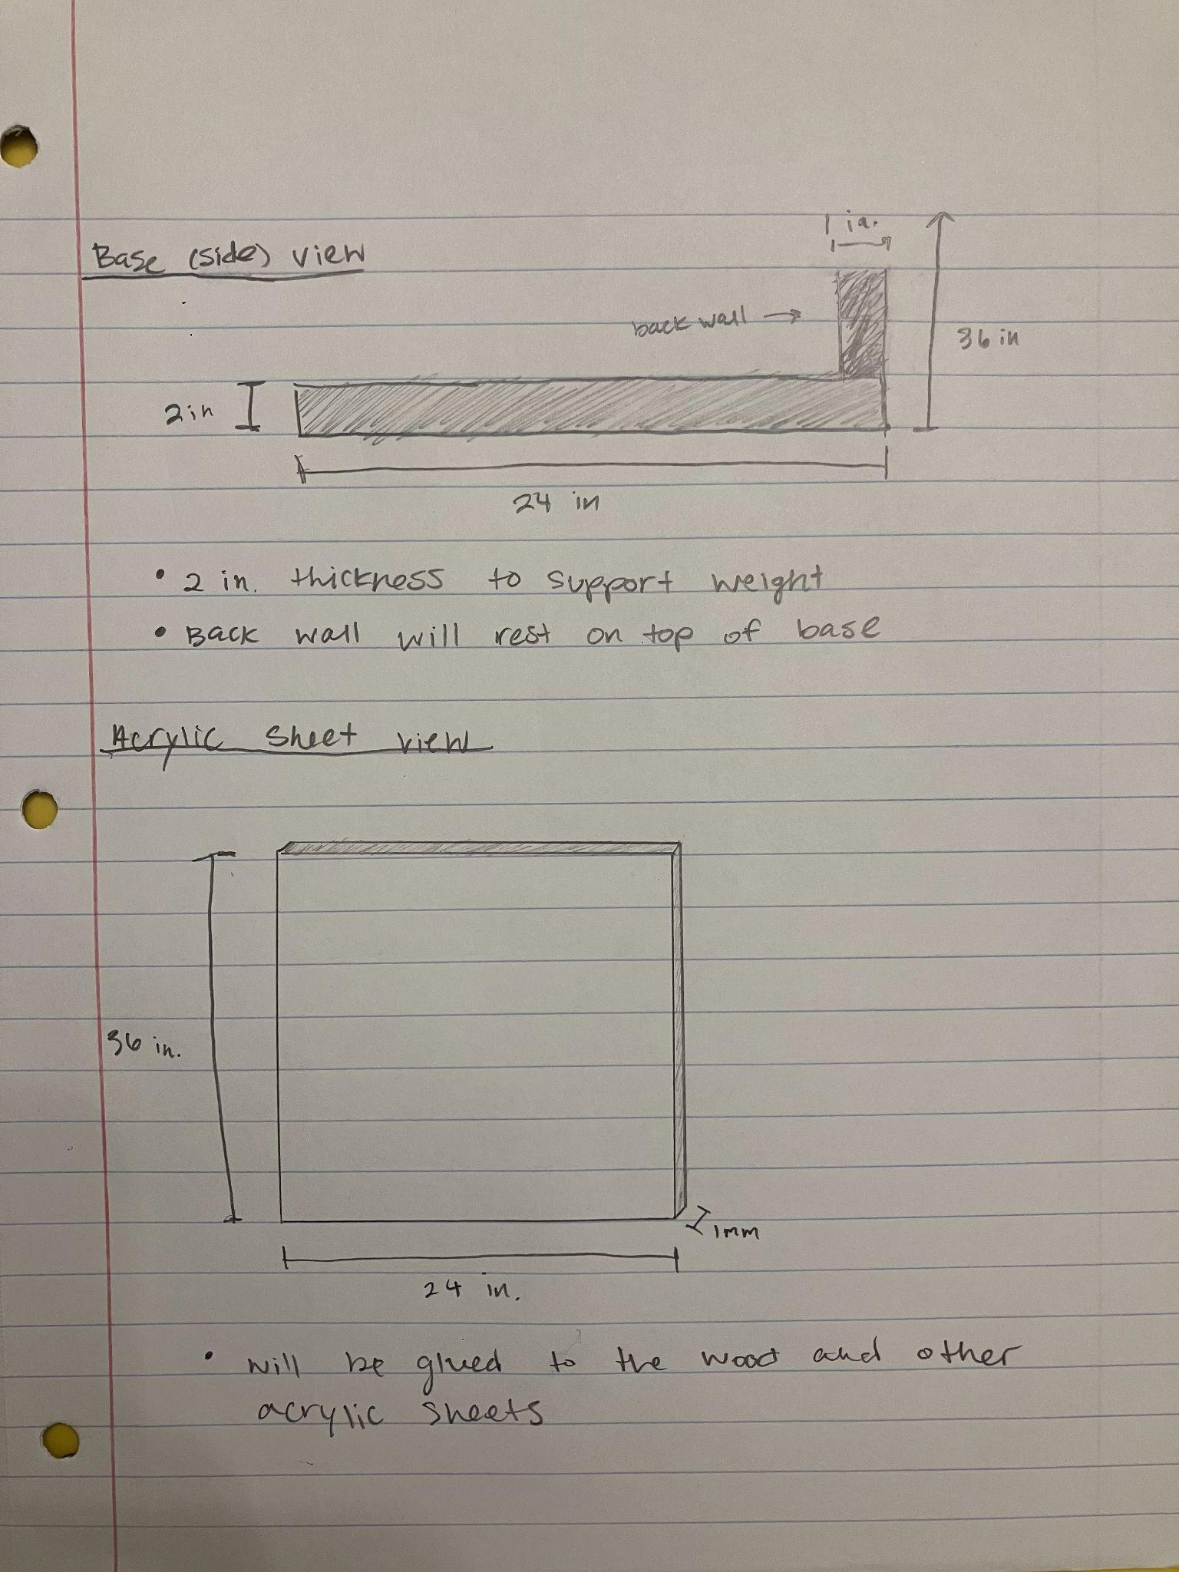

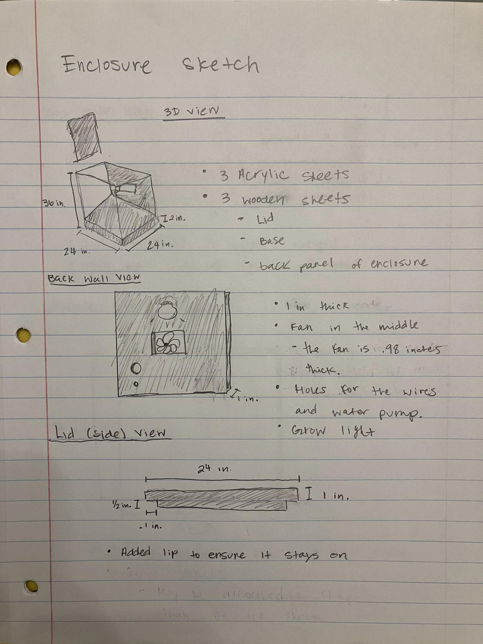

***Figure 5:*** *Gives a rudimentary glance at what the EZ-Grow enclosure should look like as well as its dimensions.*

**3D Models:**

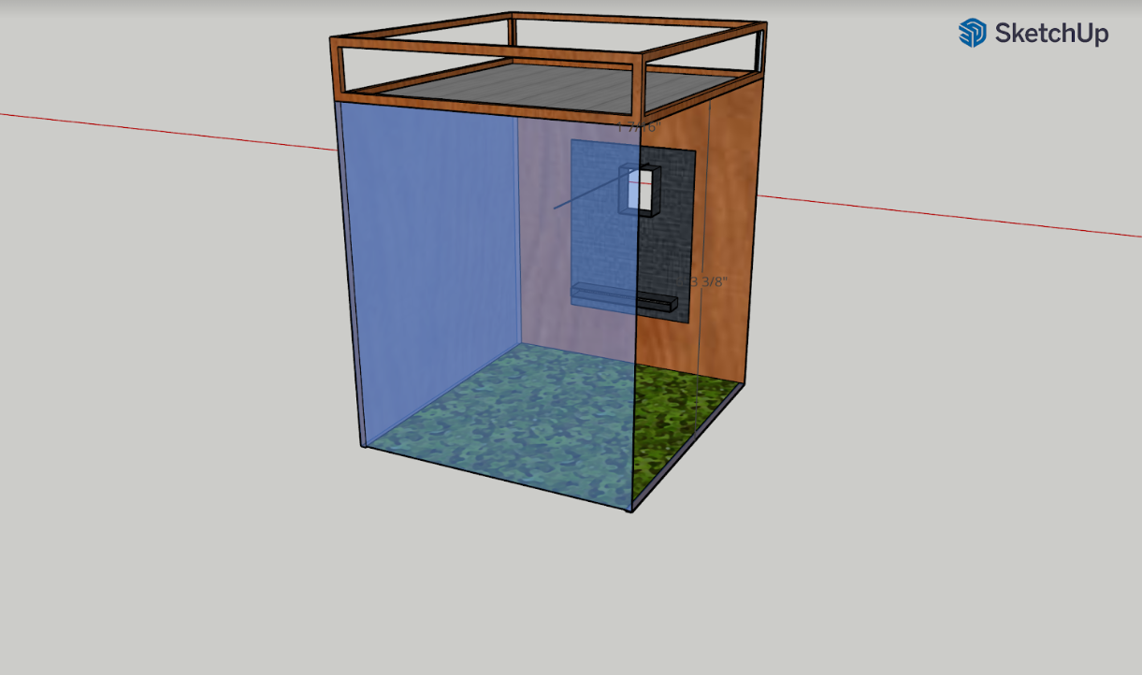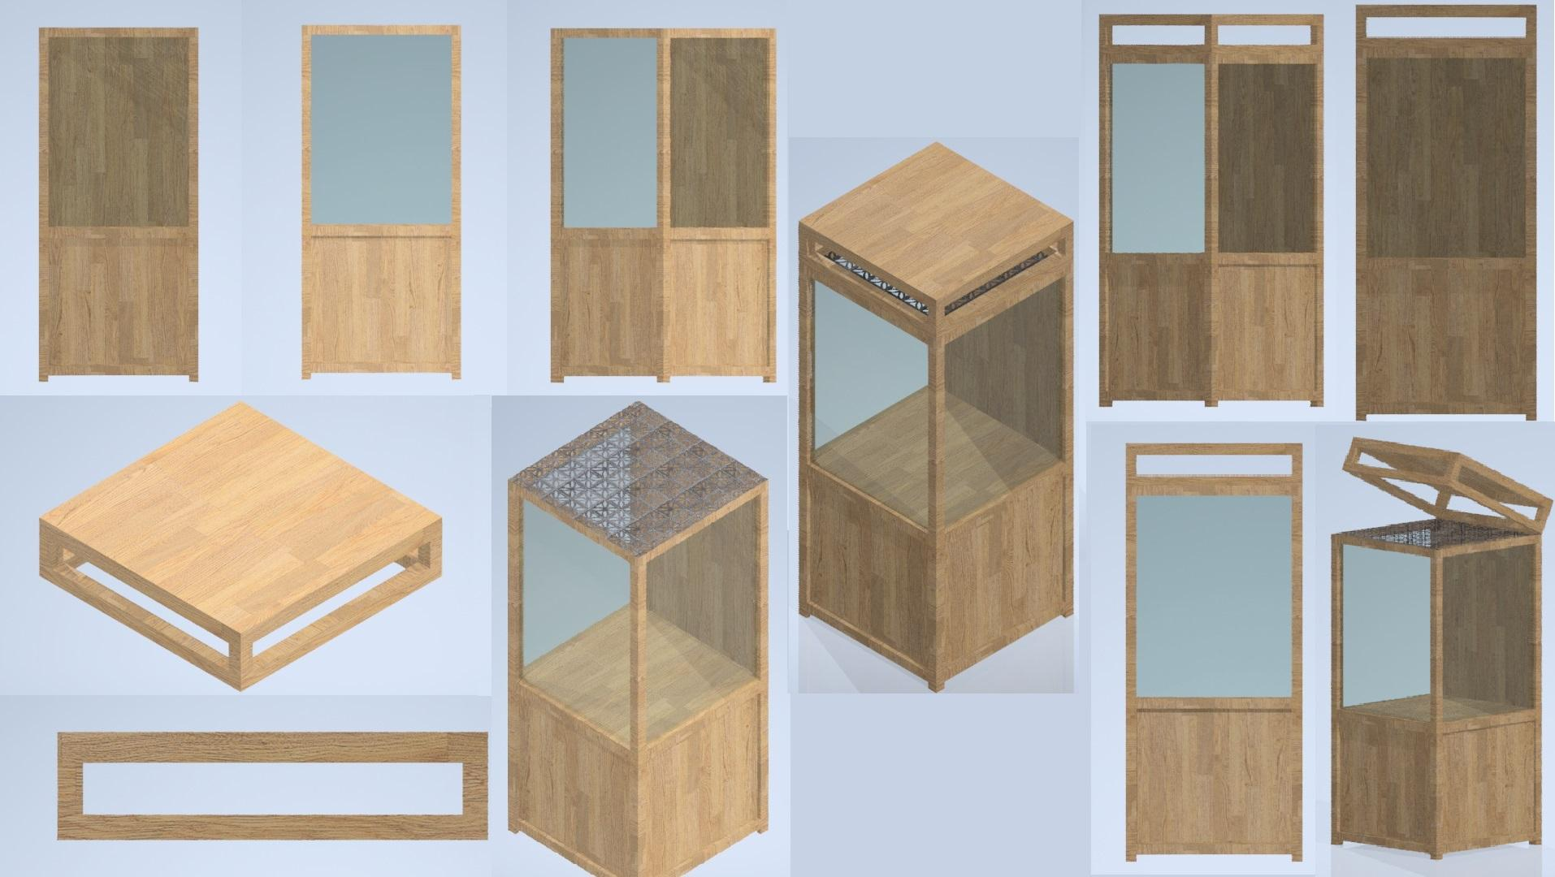

***Figure 6:*** Gives a 3D Modeled Glance into how the interior of the enclosure will look as well as the furnished exterior.

**Prototype V1:** This prototype was very important as it allowed us to see our design ideas in real life, as well as make adjustments for size and sensor placement. 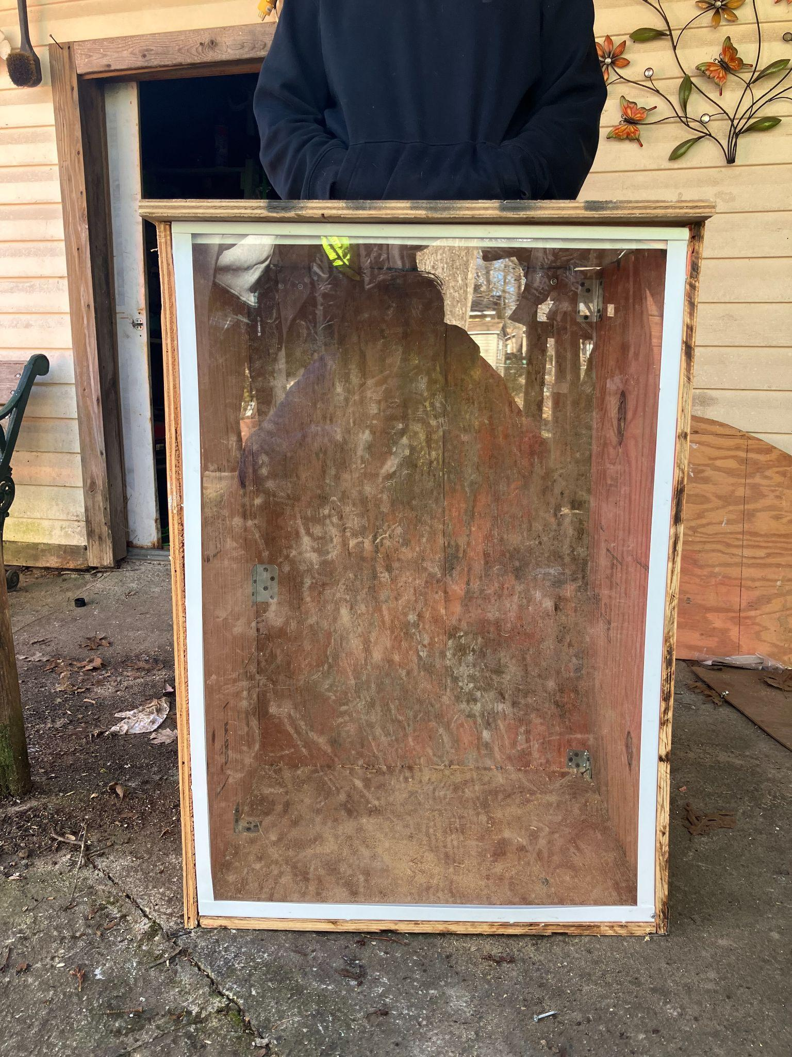

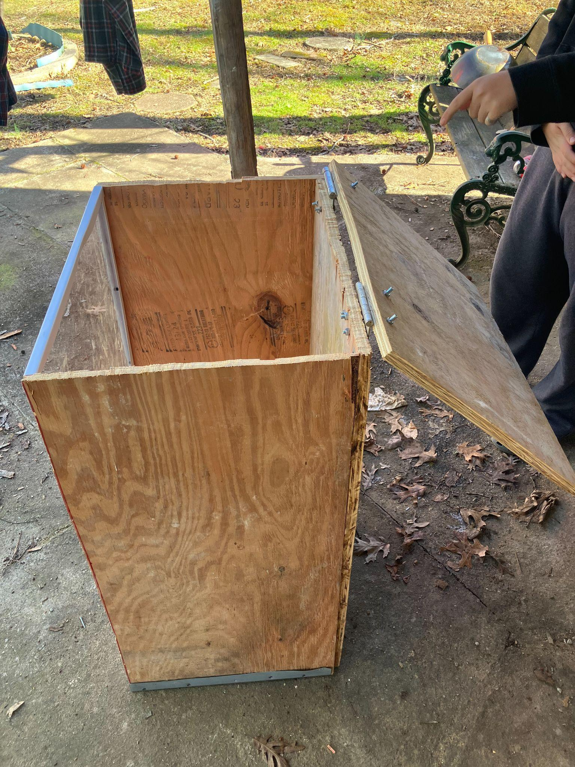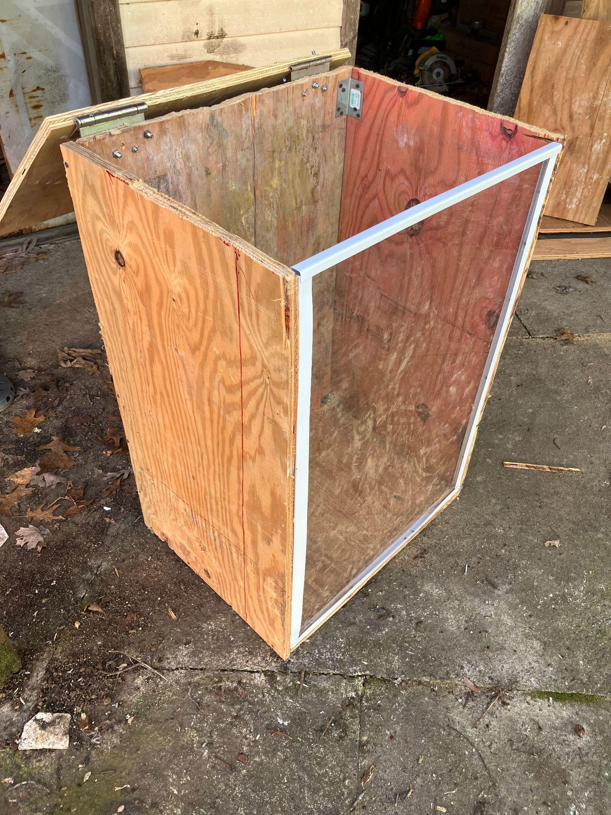

***Figure 7:*** First physical model of how the terrarium should look according to the original dimensions.

**Sensors/Actuators:**

**List of sensors and actuators:**

**-SENSORS-**

* + Humidity Sensor (DHT22)
  + Ambient Temperature Sensor (DHT22)
  + Soil Moisture Sensor (ALMCON Capacitive SM Sensor)
  + Soil Temperature Sensor
  + (DS18B20)

**-ACTUATORS-**

* + Heat Mat <= DS18B20
  + Heat Lamp <= DHT22
  + Grow Lamp <= Cloud
  + Water Pump <= ALMCON
  + Mist Maker <= DHT22
  + Fan (PC) <= DHT22

**Sensors:** A sensor is a device that detects and responds to some type of input from the physical environment. These sensors take the form of our input devices that will directly affect the signals that are sent to the actuators to keep the plant alive. Shown below are the sensors that are utilized in our design. These sensors send a signal to the relay (whenever the soil moisture sensor is too dry, dht22 reads a hot temperature or high humidity, or DS18B20 receives a temperature that's too cold). The capacitive soil moisture sensor will send a signal to the water pump, the DHT22 will send signals to the fan, and the DS18B20 will send signals to the heat mat.

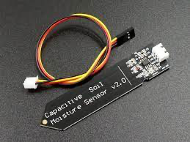

***Figure 8:*** *Capacitive SM Sensors* contain two isolated copper paths that are charged by a square wave. The capacitance is affected by its surrounding (being air and water) and moisture can be found analyzing the analog output.

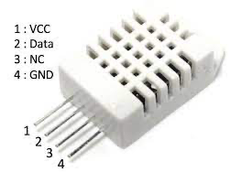

***Figure 9:*** *The DHT22* measures humidity similar to how the SM sensor measures moisture by charging 2 electrodes separated by a dielectric substrate which absorbs humidity and alters capacity. Temperature is measured by a thermistor, which changes resistance based on temp, which can then be measured through current reference.

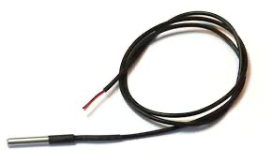

***Figure 10:*** *The DS18B20* uses a semiconductor to produce a current proportional to temperature and has a 9-12 bit ADC over a one-wire bus to produce digital output. In our design we have five actuators: the water pump, heat mat, fan, heat lamb, and the water sprinkler.

**Actuators:**

Actuators are devices that provide some sort of force through the conversion of energy. These take the form of our output devices that will directly affect the plant within the enclosure. Shown below are the main actuators that will help keep the plant in a healthy environment. They receive a signal from the microcontroller that switches a relay and allows the actuators to connect to power. The water pump will supply the misters to water the plant, the fan will cool down the enclosure and decrease humidity, and the heat mat will heat up the soil to maintain a proper soil germination level.

**[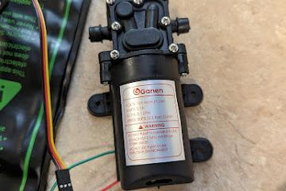](https://doc-08-c8-docs.googleusercontent.com/docs/securesc/76rllcdbl1hvmbm7hsn01q6itdkuikft/a7r9ildokhooucaqqmmpt7ojli3qt7qk/1679520075000/16882427607387128600/18154326988230722051/1kix9WR0ADOGpObZnCmBnMSTuYXgNMswP?e=download&authuser=0)**

**[](https://doc-08-c8-docs.googleusercontent.com/docs/securesc/76rllcdbl1hvmbm7hsn01q6itdkuikft/a7r9ildokhooucaqqmmpt7ojli3qt7qk/1679520075000/16882427607387128600/18154326988230722051/1kix9WR0ADOGpObZnCmBnMSTuYXgNMswP?e=download&authuser=0)*Figure 11:*** Fresh Water PumpGanen 12V DC. The water pump draws water from the left side and pushes it out of the right, requiring two (½ ID / ½ OD, tubings).

[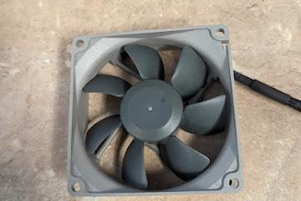](https://doc-10-c8-docs.googleusercontent.com/docs/securesc/76rllcdbl1hvmbm7hsn01q6itdkuikft/k07g6nruraaf6rous8pfbc0533gndl3i/1679520075000/16882427607387128600/18154326988230722051/1kmYy9_1r1zNBXI9O6pW0c2aePtOmcAYA?e=download&authuser=0)

[](https://doc-10-c8-docs.googleusercontent.com/docs/securesc/76rllcdbl1hvmbm7hsn01q6itdkuikft/k07g6nruraaf6rous8pfbc0533gndl3i/1679520075000/16882427607387128600/18154326988230722051/1kmYy9_1r1zNBXI9O6pW0c2aePtOmcAYA?e=download&authuser=0)[****](https://doc-08-c8-docs.googleusercontent.com/docs/securesc/76rllcdbl1hvmbm7hsn01q6itdkuikft/a7r9ildokhooucaqqmmpt7ojli3qt7qk/1679520075000/16882427607387128600/18154326988230722051/1kix9WR0ADOGpObZnCmBnMSTuYXgNMswP?e=download&authuser=0)***Figure 12:*** PC Fan. Ran from the ESP32, cools down the system and maintains a proper atmosphere for the plant.

[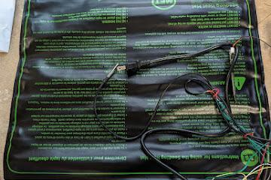](https://doc-10-c8-docs.googleusercontent.com/docs/securesc/76rllcdbl1hvmbm7hsn01q6itdkuikft/amegfpucnbap1bnun7u2qg9c7k9hrij4/1679520075000/16882427607387128600/18154326988230722051/1kYiD1TIYfJhcE4MrayBGB5UV_FiEJj3t?e=download&authuser=0)

***Figure 13:*** Heat Mat. The heat mat maintains proper soil temperature for seed germination, and keeps the seeds healthy until they bud.

**Sensor Testing:**

***Table 4:*** Testing the DHT 22 Sensor against the Acurite thermometer. Max 5% percent error.

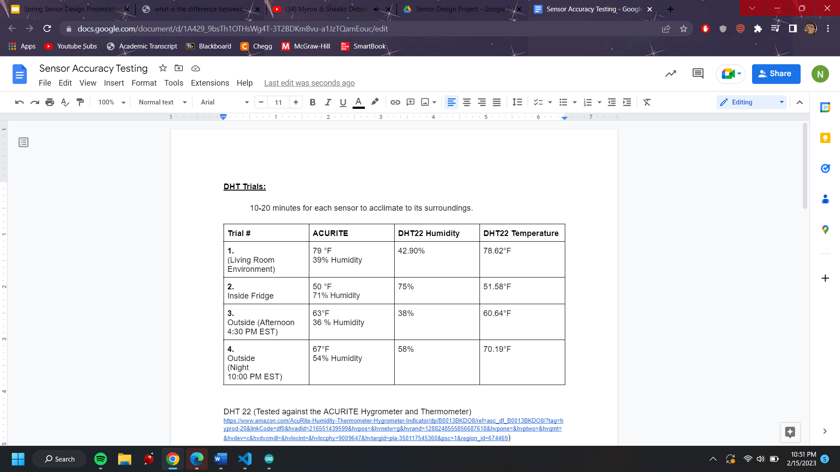

***Table 5:*** Testing Soil Moisture Sensor against the Sparkfun sensor.

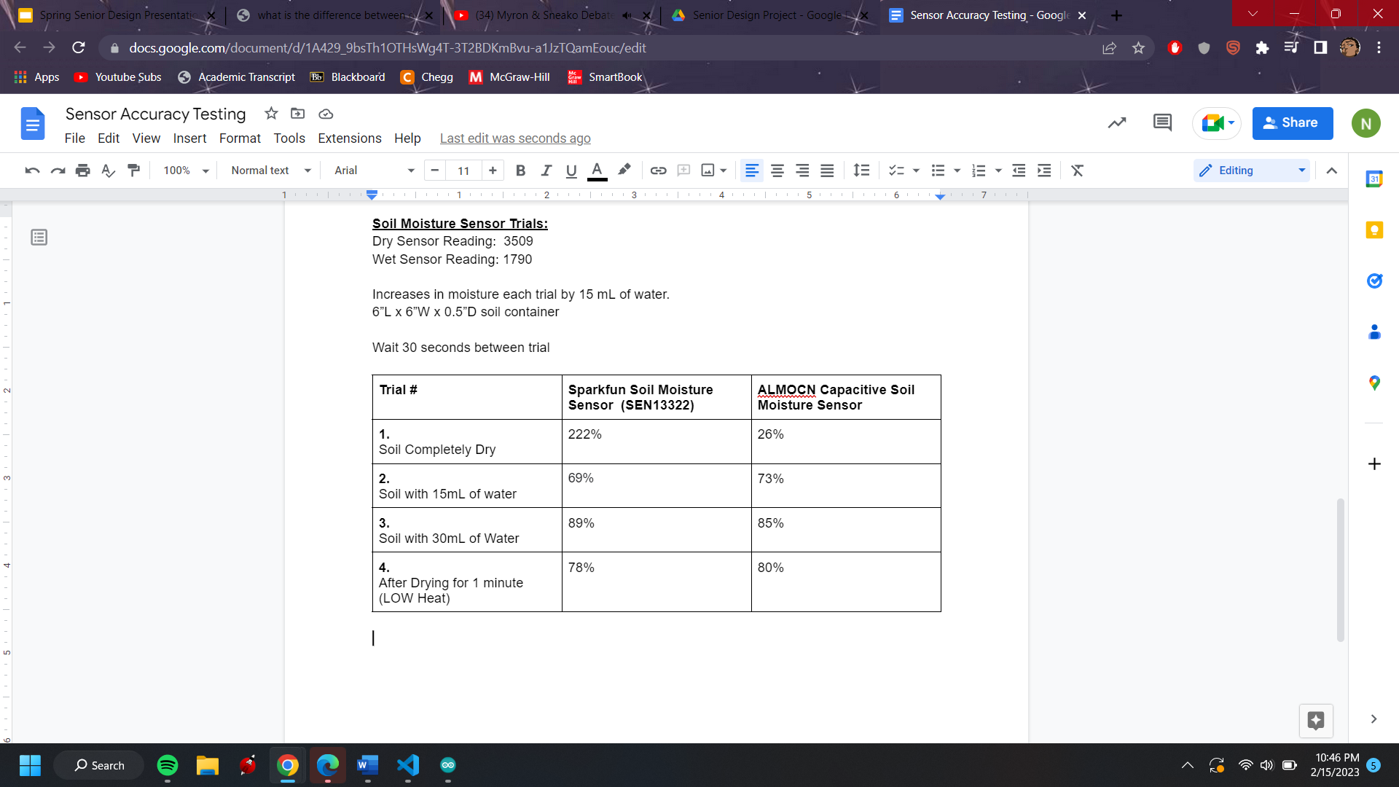

**IOT Serial Monitor Readings:**

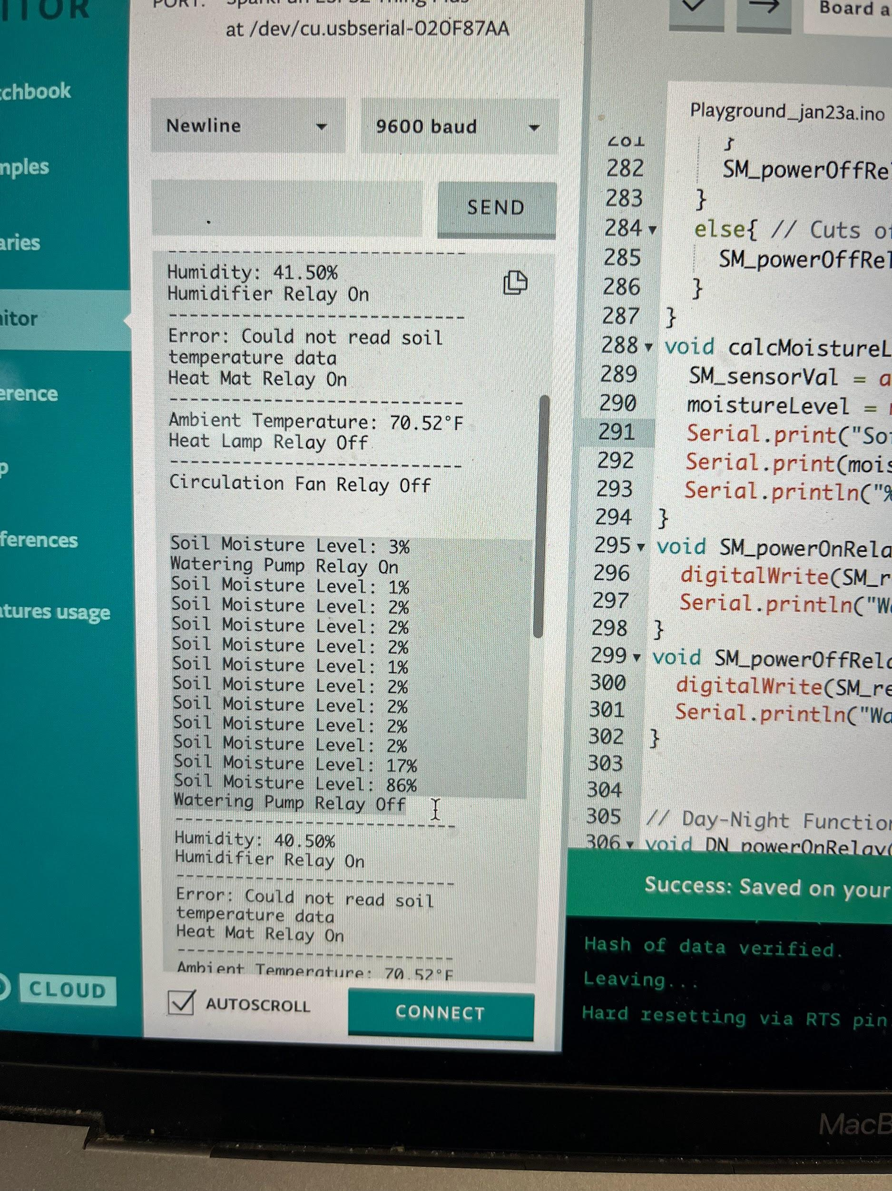

***Figure 14:*** Showing the serial monitor output for the code that we currently have written.

**Final Results:**

**IOT Dashboard:** The IOT Dashboard allows for the user to do multiple things related to the enclosure via phone or desktop. As it’s currently shown, application GUI has watering, led, temperature and humidity graph, and light scheduler features. The button allows the user to water the plant for a 3 second interval, the value button allows an LED to turn on for a user-determined amount of time, the humidity and temperature graphs track the atmosphere within the enclosure, and the light scheduler allows you to edit the grow light according to the users needs.

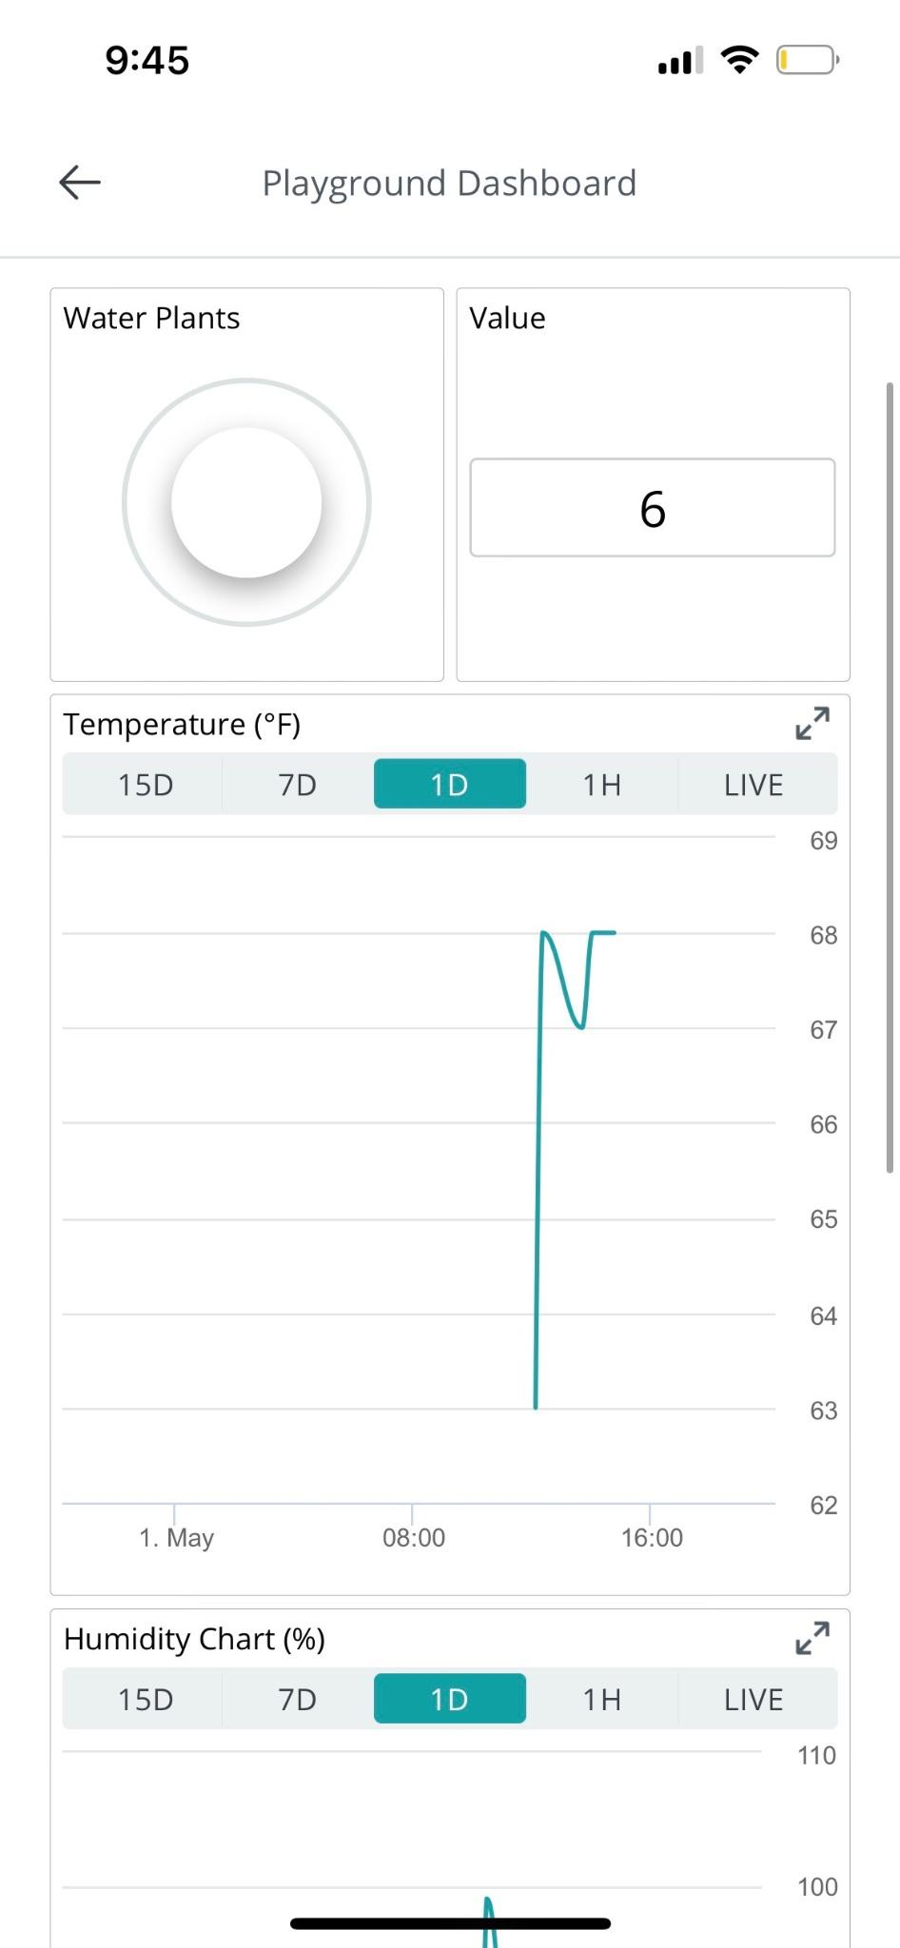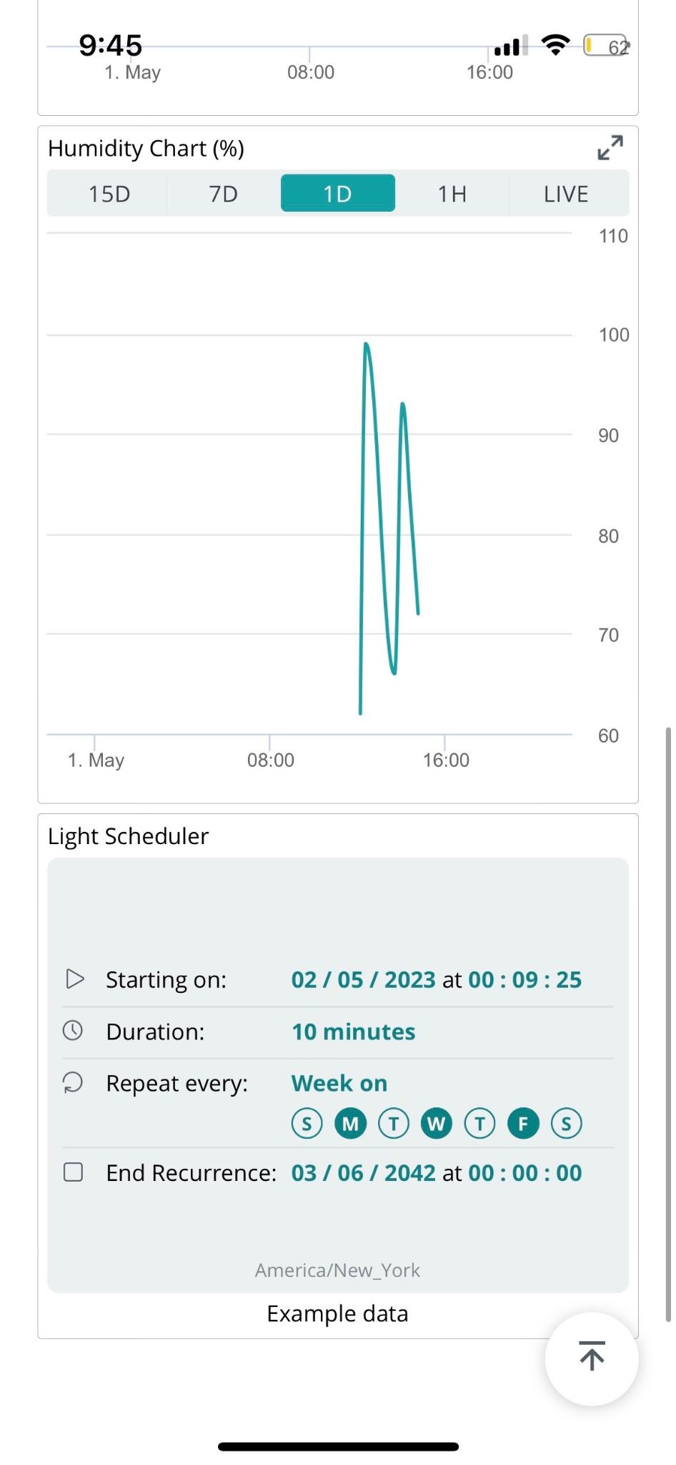

***Figure 15:*** Showing the current application dashboard from Arduino Cloud.

**Prototype V2 Enclosure:** The enclosure housed all of our sensors and actuators. It was made out of birchwood, then sanded and stained, and reinforced with polyurethane, caulk, and silicone for waterproofing. The enclosure includes, color changing LED, heat lamp, water pump, grow light, PC fan, soil moisture sensor, soil temperature probe sensor, DHT22, and lettuce.

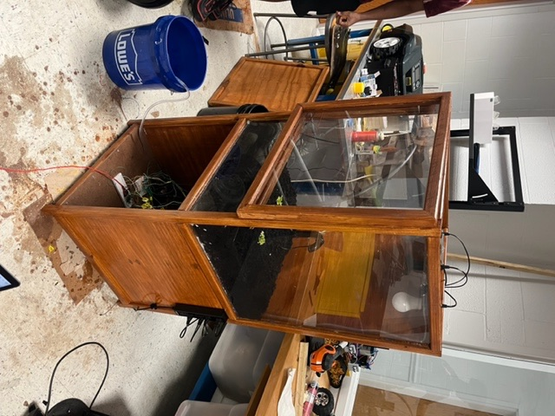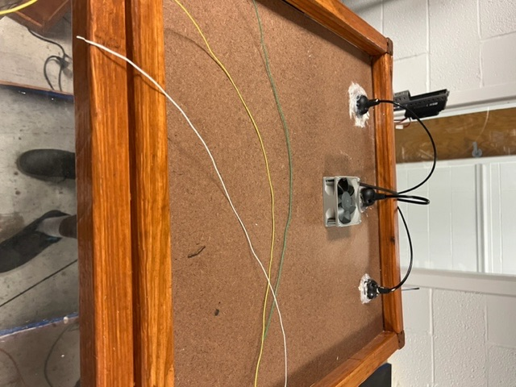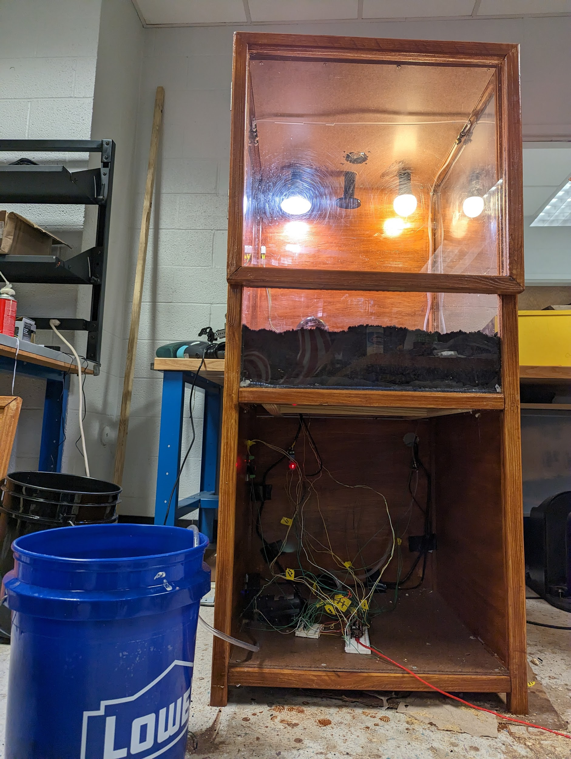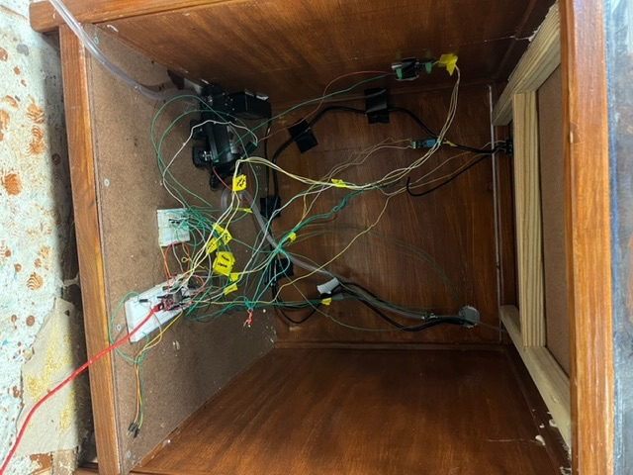

***Figure 16:*** Showing the Prototype V2 of the enclosure.

**Unexpected Issues and Innovative Solutions:** This section includes things that happened during the construction of prototypeV2 and forced us to make necessary adjustments to the design.

1. We came across an issue with some of our actuators that required a larger voltage (12V), where there would be a humming or repeated switching of the relay. This humming made the enclosure sound very electrically insecure. *To help fix this situation* we added a BJT solution that smoothed out the electrical flow within our enclosure. **(BJT Solution Pictured on Figure 26).**
2. Many of our sensors and actuators required soldering to be electrically safe inside of the terrarium (as well as to make the wires longer). *To help fix this* The DHT22 required soldering, ds18b20, as well as all the relays for the actuators.
3. There was no stopping pin for misters so the water flow around the terrarium was unable to stop. *To fix the problem* we wedged a screw in the end and applied our silicon around it to make it secure.
4. There was an issue with the design where we forgot the need for the user to look into and freely access the plant that they were growing. *To fix this problem* we added in the function of a door, with magnets as a locking mechanism. In the future we would make this flush with the design or less thick overlay.
5. There was no wifi at the school in the Monroe building, which made it difficult for us to test our Internet of Things (IoT) portion of the capstone project. To fix this problem we created a wifi point using an old modem and a lan cable.
6. Because we had so many sensors and actuators, we had to make sure our wires were secure,concealed, and labeled. *To fix this problem* we had to electric tape each set of lines from each sensor with a label, and then duct tape those wires to the back of our enclosure. This kept the wires out the way and allowed us to keep the enclosure safe. In the future we would get a 3D printed wirebox to encapsulate wires.

**Conclusion:**

**Design Phase:**

To conclude, this project is designed to explore creative new options for crop production on a personal scale by using sustainable methods, while also conserving space through the use of a terrarium. Our product will solve this problem by using everyday technology to innovate a way to grow plants without a direct human influence. In order to start research we first had to figure out the constraints of the plant we’ll use (to properly create margins), the technology needed to invent such a device, and how to market our product. After consulting with the agriculture department, they helped us decide to go with lettuce as our main plant. We have made a list of parts needed to create a terrarium, and the best method in order to market our product to the consumer. We also have developed a working time frame in which our product will be completed. The self-sustaining terrarium is designed to grow a plant without human interaction. This will be accomplished purely through technological means. We believe that our product will better the agriculture industry and benefit humanity as a whole.

**PrototypeV1:**

After going through the first testing phase of our project, we can say that we have almost successfully gotten each model up and running. As far as the enclosure: we have gone from a simple paper sketch, to a 3-D model, all the way to a completely built PrototypeV1. Although our prototype for the enclosure isn’t up to our standards, it allowed us to make educated decisions on how to revise our next prototype. When dealing with the sensors and actuators, we have every sensor up and working (aside from a faulty temperature probe), and we were also able to test the sensors for accuracy. Our testing went far better than expected as we were able to bring the percent error to lower than 3% for ⅔ sensors. When looking at the actuators we have each relay soldered and up and working, as well as the code for the sensors and actuators to communicate. Finally, in regard to the IoT, we have the basis of the application created as well as the application to breadboard communication. In addition to this, all of our code works through the arduino cloud, which should make the integration to the app much easier. After testing phase with PrototypeV1, we are very pleased with our progress thus far and look forward to the future possibilities of this project.

**PrototypeV2:**

After going through the second testing phase of our project, completing PrototypeV2, we can say that we have gotten a fully operational model working.

*As far as the enclosure:* We have gone from a paper sketch, to a 3-D model, to PrototypeV1, to a sanded, stained, and complex PrototypeV2. Although the prototype isn’t exactly where we would want our final product to look like, it is fully operational and will be a nice piece of furniture for up to 5 years. If we were to improve any piece with the enclosure of PrototypeV2, we would likely add the door to be in flush with the design, as well as a 3-D printed wire box to make sure that the ESP was secured. We would also use a different material than wood to make the furniture last much longer.

*As far as the sensors and the actuators:* We have gone from programming them individually, to integrating them together, to finding their place in a fully functioning system. Our system is fully functional, however with the code commanding the sensors could be custom tailored to run more based off of the lettuce instead of a more basic demo package. If we were to make any changes here, we would have a more custom grow light cycle and a more custom humidity preference.

*As far as the IOT:*We have gone from having no application interface, to a partially working application interface, to a fully functional online platform. Our application system is fully functional (aside from the grow light scheduler). If we were to fix anything here, we would create our own application for the users to use instead of using Arduino’s version.

**References:**

1. Martin, Tovah. “How to Make a Terrarium - DIY Terrarium Tips - Garden Design.” *GardenDesign.com*, Garden Design Magazine, 4 Apr. 2022, <https://www.gardendesign.com/how-to/terrarium-tips.html>
2. Michaels, Kerry. “How to Make a Basic Terrarium.” *The Spruce*, <https://www.thespruce.com/how-to-make-terrariums-848007>
3. Walsh, Elliot. “Plants That Grow Fast for Science Projects.” *Sciencing*, 30 July 2019, <https://sciencing.com/plants-grow-fast-science-projects-5764397.html>
4. P. Dyer (not, et al. “Basil.” *Almanac.com*, <https://www.almanac.com/plant/basil>
5. “Arduino - Soil Moisture Sensor: Arduino Tutorial.” *Arduino Getting Started*, <https://arduinogetstarted.com/tutorials/arduino-soil-moisture-sensor>
6. *Electronic Components Distributor - Mouser Electronics*. <https://www.mouser.com/datasheet/2/737/dht-932870.pdf>
7. *Click DS18B20 Prorammale Resolution 1-Wire Digital Thermometer*. <https://datasheets.maximintegrated.com/en/ds/DS18B20.pdf>
8. Gillis, Alexander S. “What Is IOT (Internet of Things) and How Does It Work? - Definition from Techtarget.com.” *IoT Agenda*, TechTarget, 4 Mar. 2022, <https://www.techtarget.com/iotagenda/definition/Internet-of-Things-IoT>
9. “Documentation for Blynk, the Most Popular IOT Platform for Businesses.” *Docs.blynk.cc*, <https://docs.blynk.cc/>
10. “7 Top-Rated Indoor Garden Kits and Systems to Shop in 2022.” *NBCNews.com*, NBCUniversal News Group, <https://www.nbcnews.com/select/shopping/best-indoor-garden-kits-ncna1267376>

**Appendices:**

**Decision Matrices:**

**HUMIDITY SENSOR:**

**Table 5:** *The Decision Matrix for which humidity sensor to use*

|  | **COST (20)** | **TEMP ACCURACY (40)** | **HUMIDITY ACCURACY (40)** | **TOTAL:** |
| --- | --- | --- | --- | --- |
| **AM2320** | **4** | **5** | **3** | **400** |
| **DHT11** | **5** | **3** | **4** | **380** |
| **DHT22** | **3** | **5** | **4** | **460** |

**TEMPERATURE SENSOR:**

**Table 6:** *The Decision Matrix for which temperature sensor to use*

|  | **COST (20)** | **TEMP ACCURACY (70)** | **OP VOLTAGE RANGE (10)** | **TOTAL:** |
| --- | --- | --- | --- | --- |
| **DS18B20** | **5** | **5** | **3** | **480** |
| **TMP36** | **4** | **3** | **4** | **330** |
| **LM335** | **4** | **4** | **4** | **460** |

**MICRO CONTROLLER;**

**Table 7:** *The Decision Matrix for which microcontroller to use*

|  | **ARDUINO NANO w/ ESP8266ESP01** | **RASPBERRY PI PICO** | **ESP 32** |
| --- | --- | --- | --- |
| **COST (25)** | **3** | **5** | **4** |
| **COMPACT (20)** | **4** | **5** | **5** |
| **EASY TO CODE (15)** | **5** | **3** | **4** |
| **AVAILABLE I/0 (25)** | **5** | **5** | **3** |
| **VOLTAGE SUPPORT (20)** | **5** | **3** | **3** |
| **Total** | **455** | **455** | **415** |

**Alternative Designs:** 

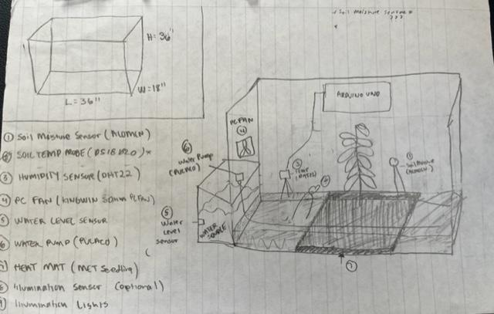

***Figure 17:*** *Alternative Design*

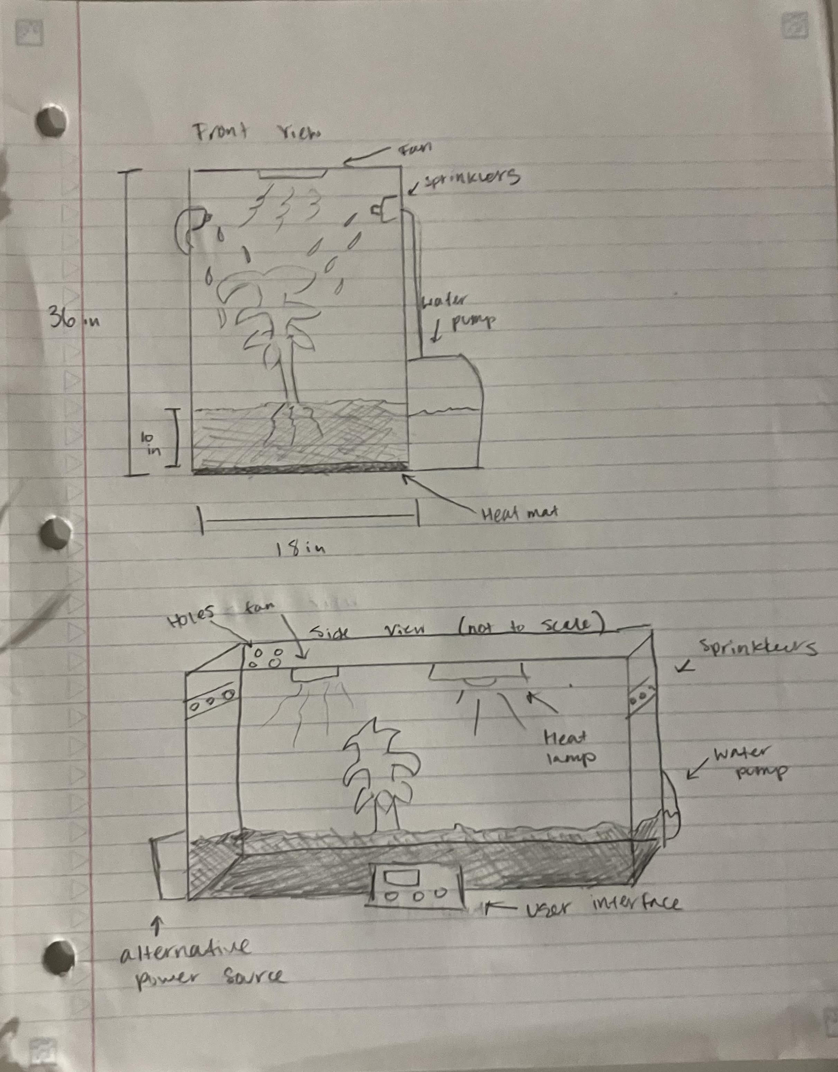

***Figure 18:*** *Alternative Design*

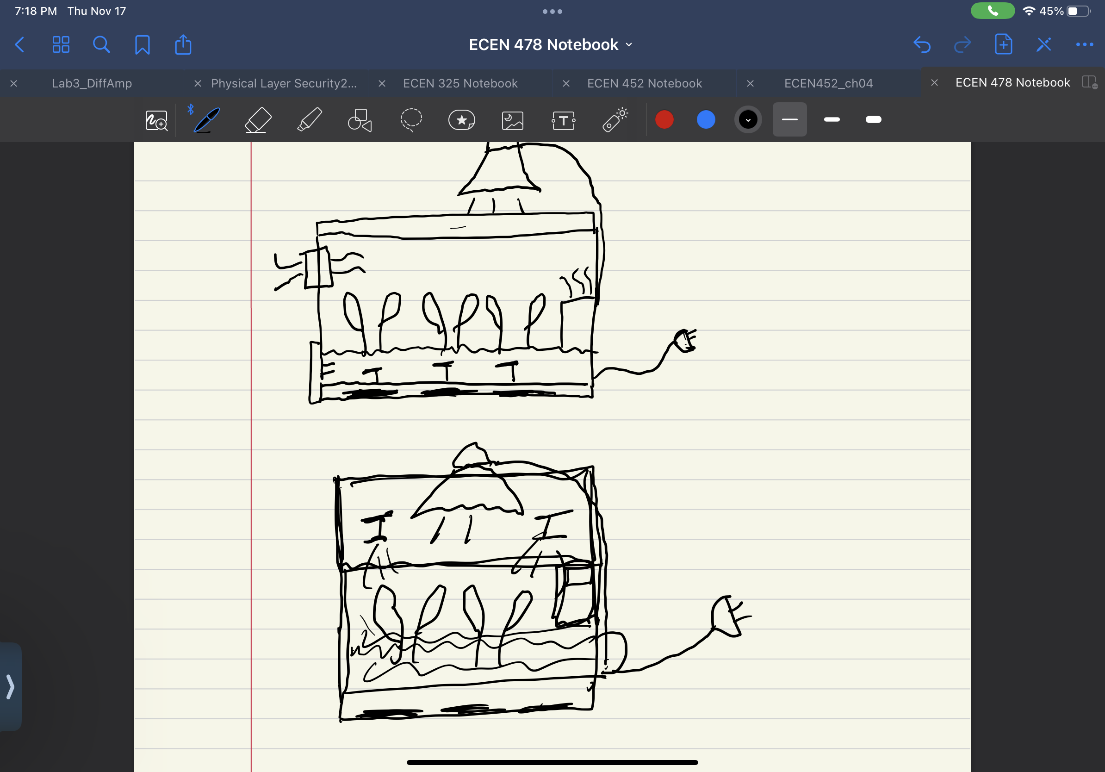

***Figure 19:*** *Alternative Design*

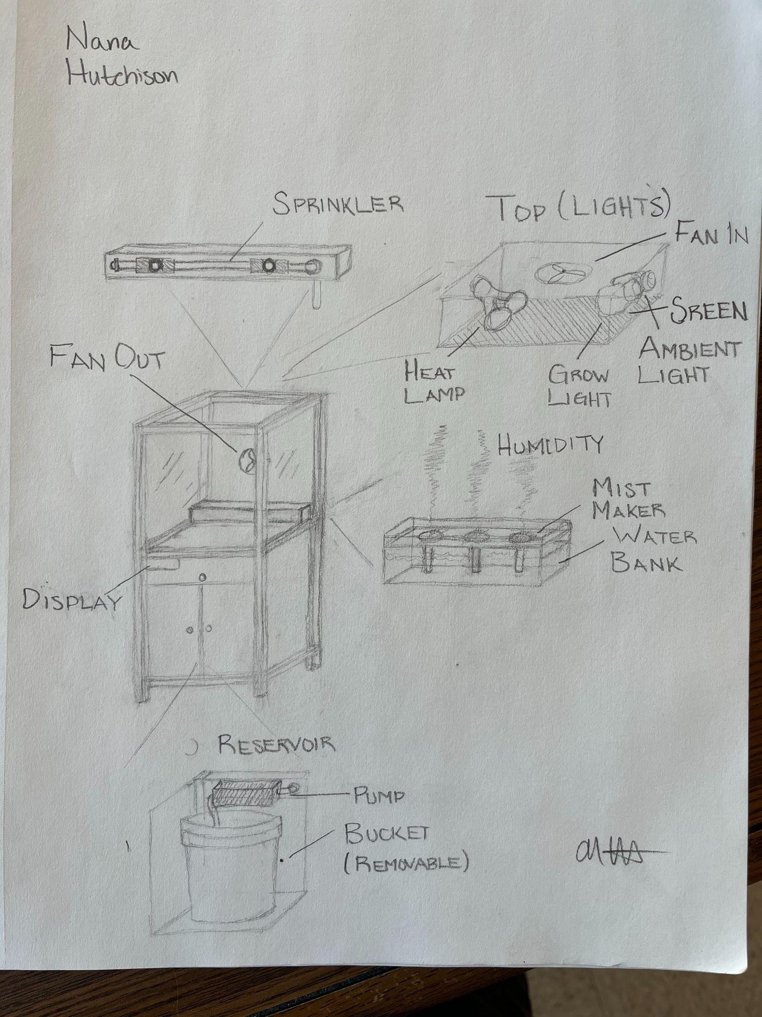

***Figure 20:*** *Alternative Design*

**Experimental Photos/Videos:**

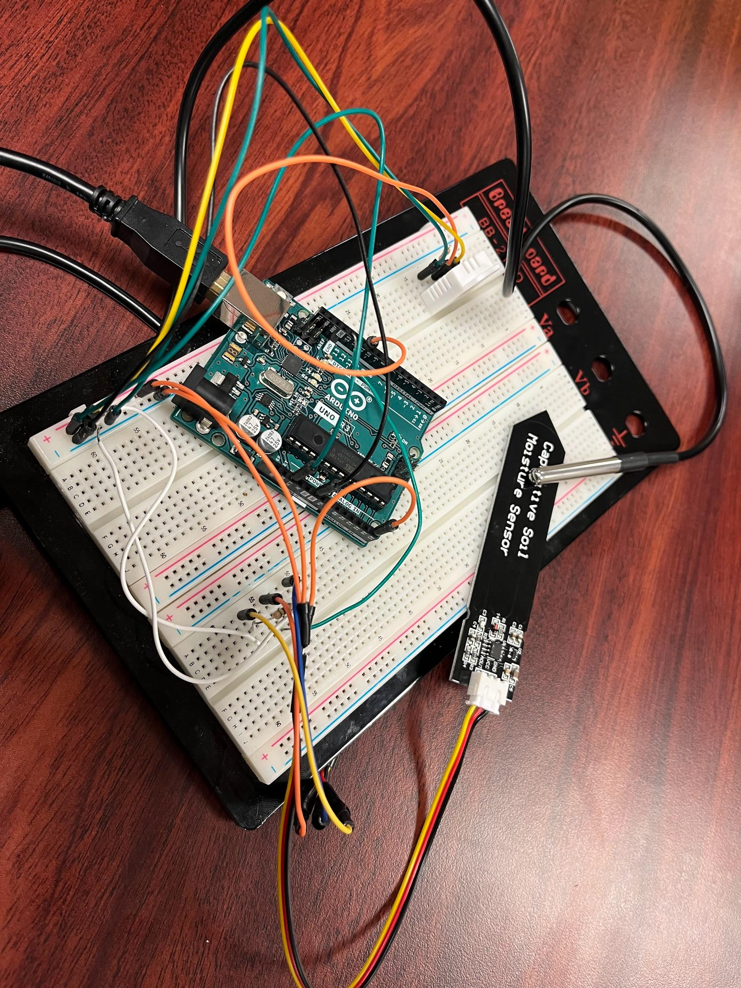

***Figure 21:*** *Arduino Setup*

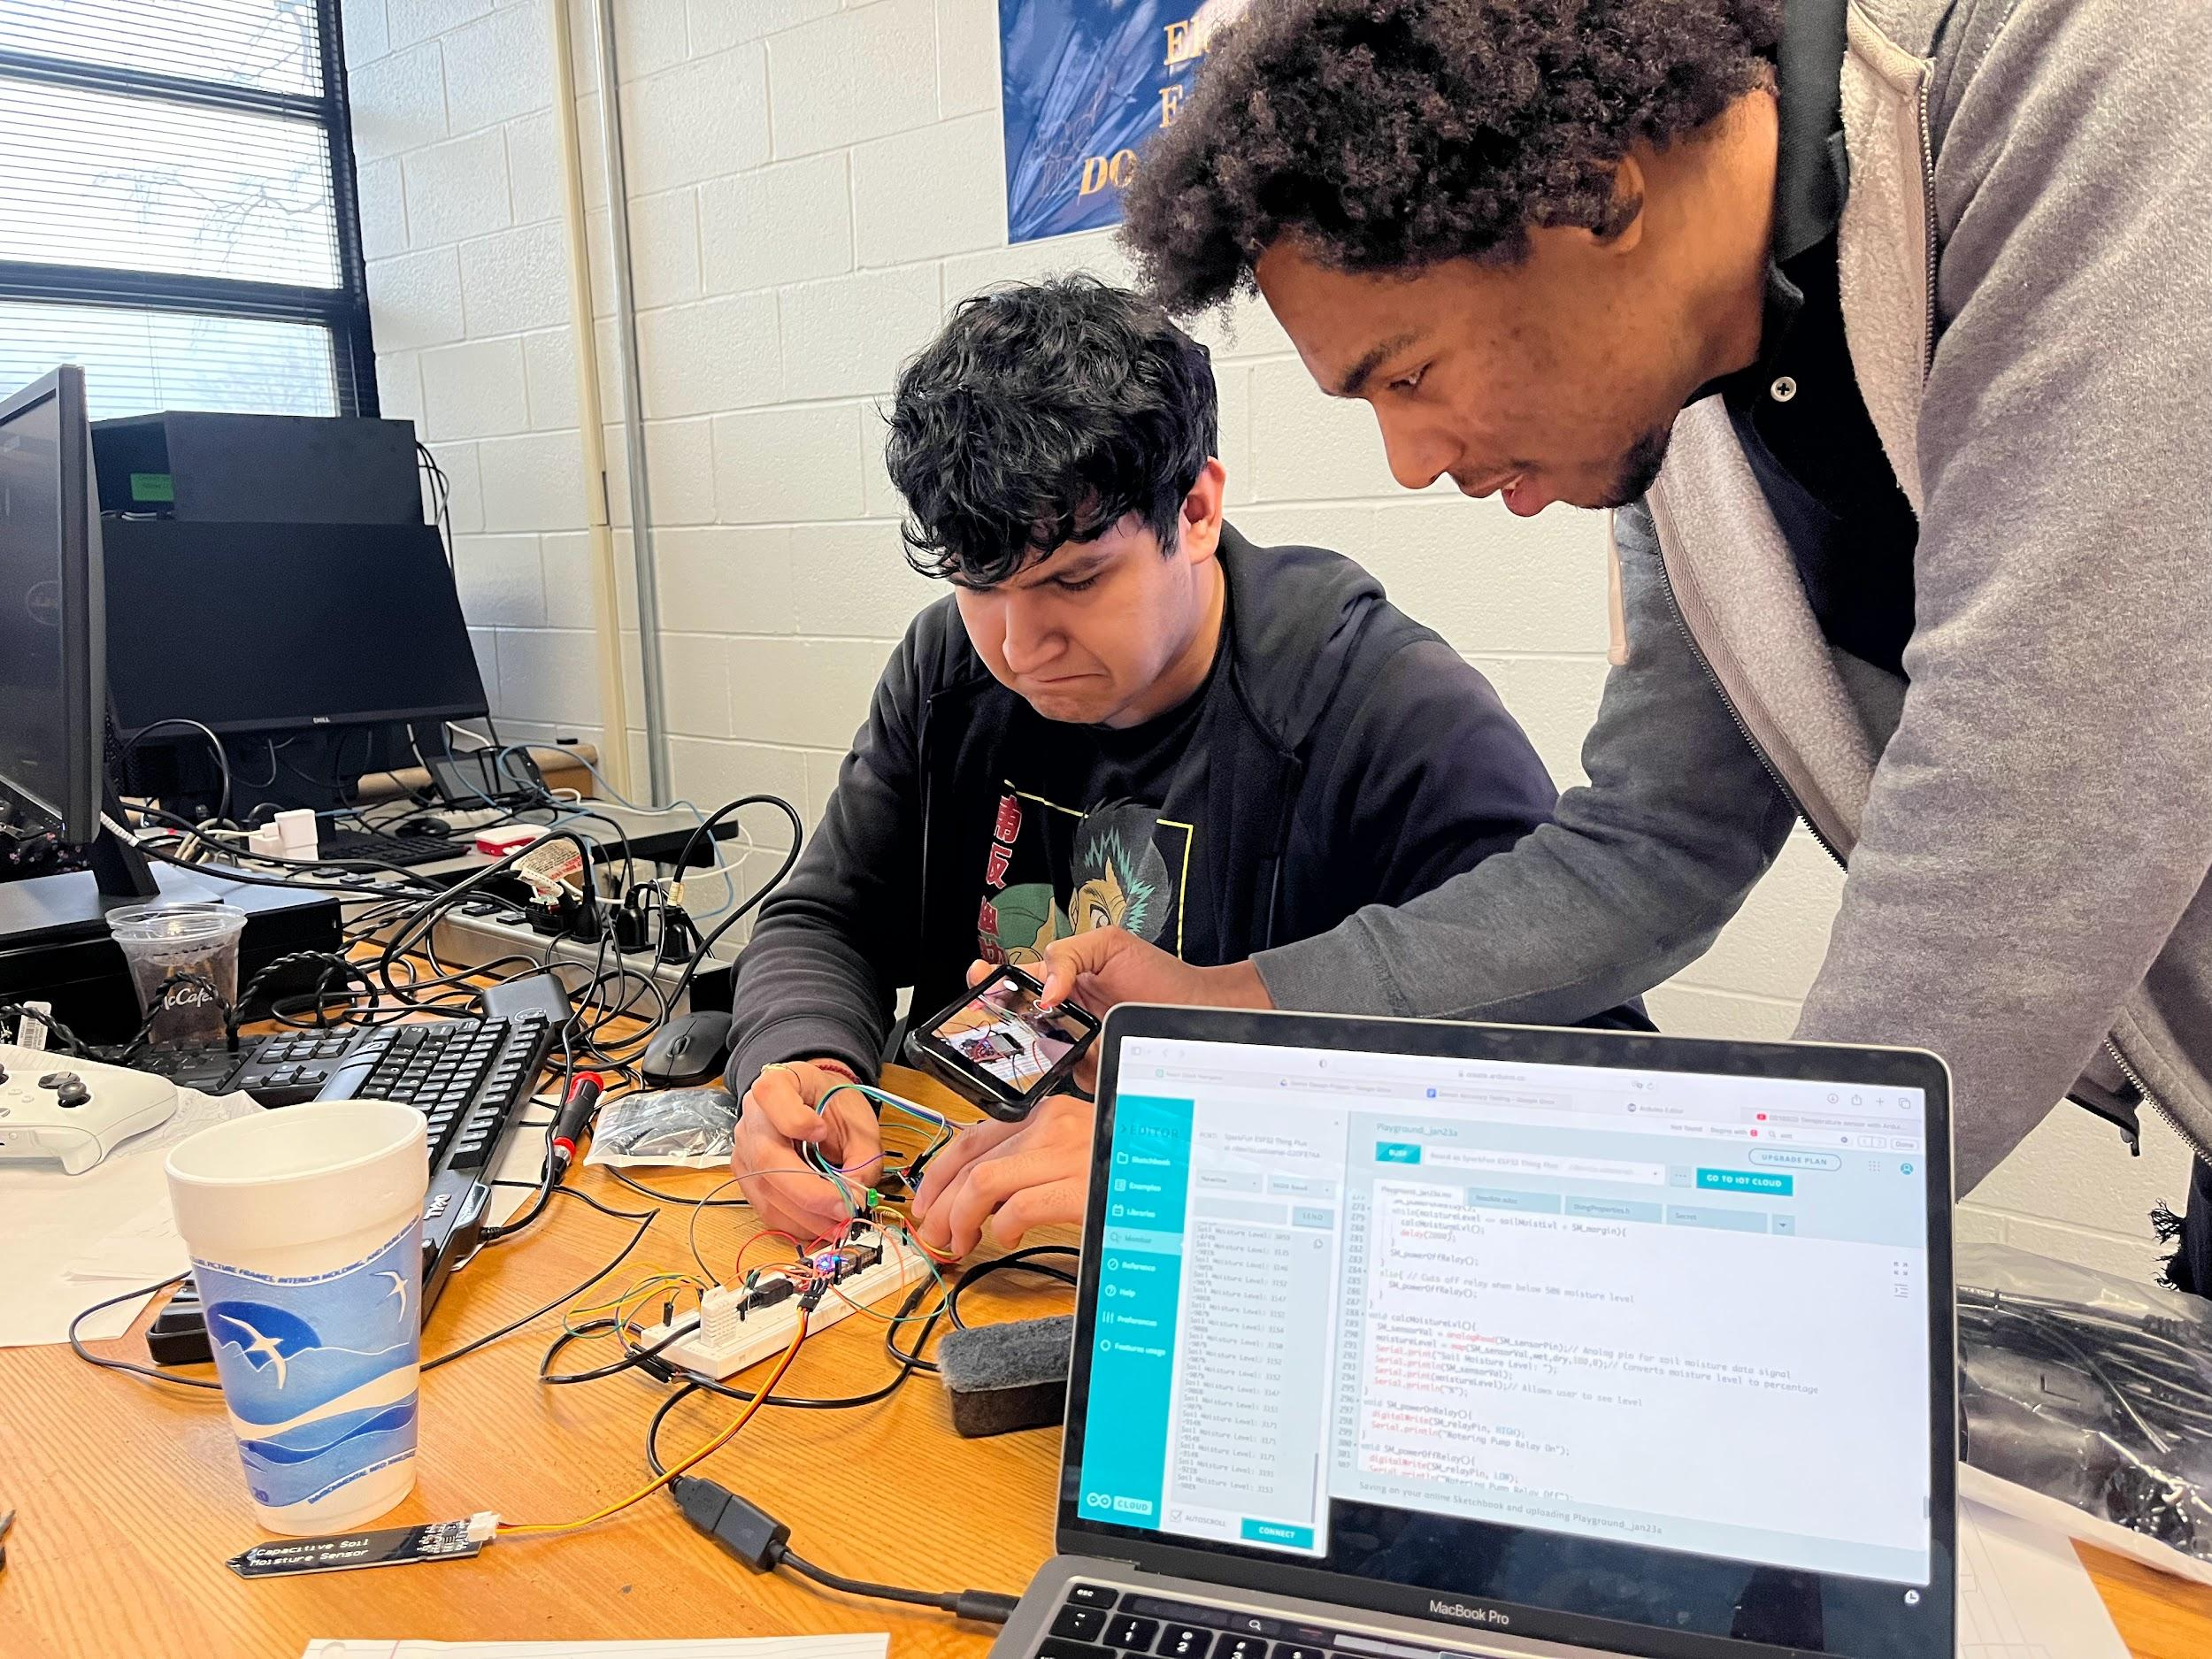

***Figure 22:*** *Relay Construction*

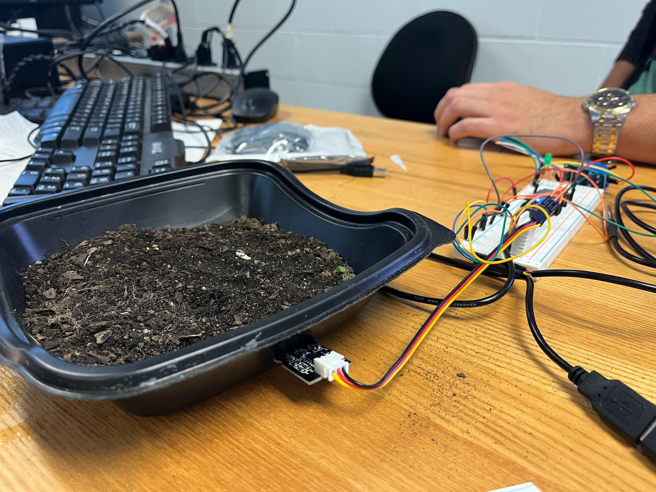

***Figure 23:*** *Soil Moisture Testing*

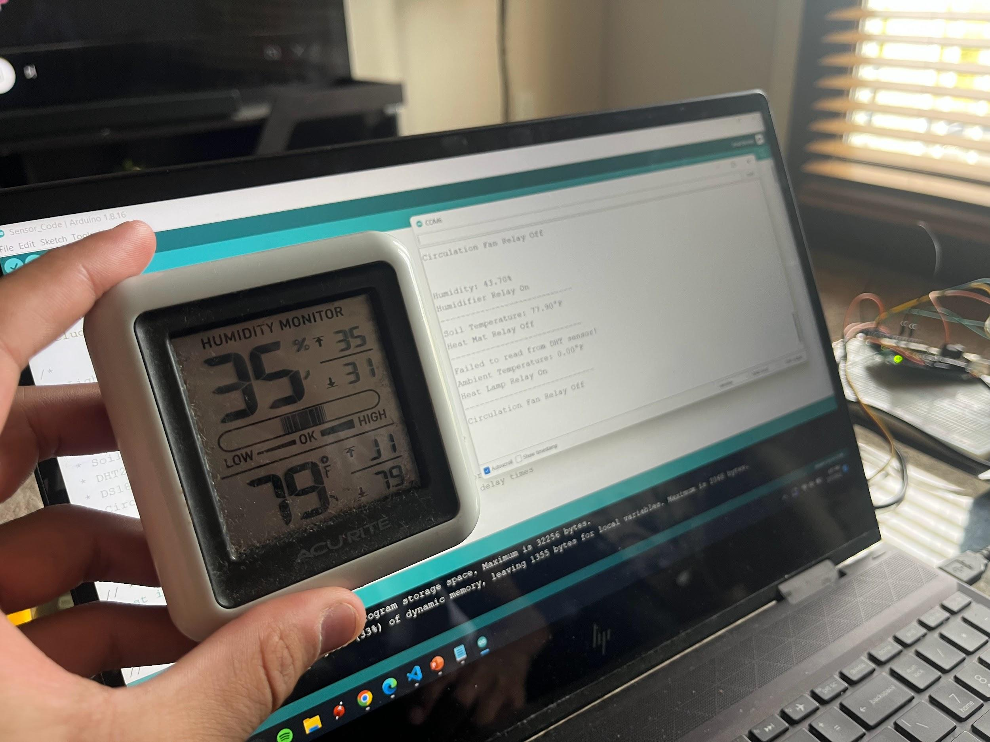

***Figure 24:*** *Temperature / Humidity Testing*

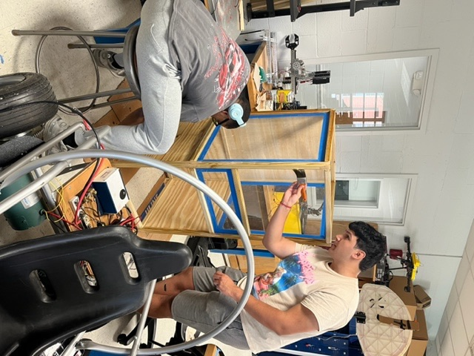

***Figure 25:*** *PrototypeV2 Construction*

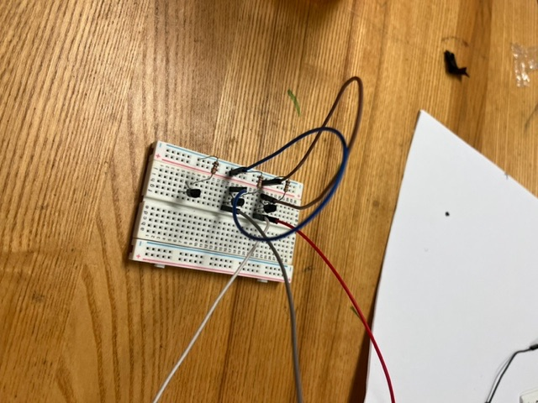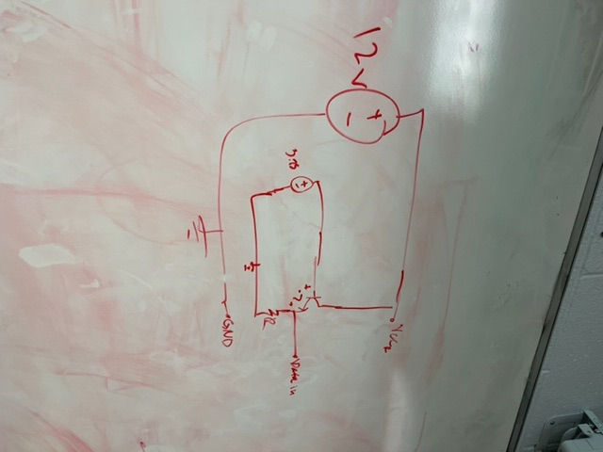

***Figure 26:*** *BJT Amplifier Solution*

**Source Code:**

#include "DHT.h"

#include <OneWire.h>

#include <DallasTemperature.h>

#include "thingProperties.h"

/*

Lighting Relay Pin: PIN-D19. 15* good

Watering Pump Relay Pin: PIN-D12 good

Heat Mat Relay Pin: PIN-D32 good

Fan Relay Pin : PIN-D13 good

Heat Lamp Relay Pin: PIN-D25 25* good

Humidifier Relay Pin: PIN-D?

Soil Moisture Sensor Analog Pin: A4 (GPIO 36)

DHT22 Data Pin: PIN-D14 good

DS18B20 Data Pin: PIN-D21

*/

bool inCelcius = false; // Celcius or Fahrenheit Readings?

// *** day night cycle vars

const int DN_relayPin = 19; // Day Night Cycle data line for relay signal input

int dayTimeDelay = 3500, nightTimeDelay = 7000; // Set delay times

// ***

// *** soil moisture vars

const int SM_sensorPin = 36; // Soil Moisture sensor analog input line

const int SM_relayPin = 12; // Soil Moisture data line for relay signal input (water pump)

const int dry = 3295; // Highest Dry value from analog soil moisture reading

const int wet = 2260; // Lowest Wet value from analog soil moisture reading

int soilMoistLvl = 15; // Soil moisture level for relay

int SM_sensorVal, moistureLevel; // Moisture level calculation vars

int SM_margin = 5; // set allowable control margin

// int SM_delay = 3000; // Set test interval

// ***

// *** soil temperature vars

// -- DS18B20 Setup

#define ONE_WIRE_BUS 21 // Data wire port on the Arduino is??? (21)

OneWire oneWire(ONE_WIRE_BUS); // Setup a oneWire instance to communicate with any OneWire device

DallasTemperature sensors(&oneWire); // Pass our oneWire reference to Dallas Temperature

DeviceAddress insideThermometer; // arrays to hold device address

// --

const int ST_relayPin = 32; // Soil Temperature data line for relay signal input

float soilTempLvl = 75.0; // Soil temp level for relay

float ST_margin = 2.0; // set allowable control margin

bool STrelayOn = 0;

// int ST_delay = 250; // Set test interval

/// ***

// *** air temperature & humidity vars

// -- DHT22 Setup

#define DHTPIN 14 // Digital pin connected to the DHT22 sensor

#define DHTTYPE DHT22 // DHT 22 (AM2302)

DHT dht(DHTPIN, DHTTYPE);

// --

//On Board LED

int LED = 13;

const int AT_relayPin = 25;

const int AH_relayPin = 32;

float airTempLvl = 75.0;

float airHumidLvl = 55.0;

float AT_margin = 5.0;

float AH_margin = 5.0;

// int AT_delay = 3000;

// int AH_delay = 3000;

bool fanQue = false; // initialize fan que off

const int Fan_relayPin = 13; // fan relay singal pin

void setup() {

Serial.begin(9600);

Serial.println();

pinMode(DN_relayPin, OUTPUT); // Set up Day Night pin registers

pinMode(SM_relayPin, OUTPUT); // Set up Soil Moisture pin register

pinMode(ST_relayPin, OUTPUT); // Set up Soil Temperature pin register

pinMode(AT_relayPin, OUTPUT); // Set up Air Temperature pin register

pinMode(AH_relayPin, OUTPUT); // set up Humidity pin register

pinMode(Fan_relayPin, OUTPUT); // Set up Circulation Fan pin register

pinMode(LED, OUTPUT);

dht.begin();

sensors.begin();

// DHT22 setup arguments

if (!sensors.getAddress(insideThermometer, 0)) Serial.println("Unable to find address for Device 0");

sensors.setResolution(insideThermometer, 9);

// initialize relays off

AH_powerOffRelay();

AT_powerOffRelay();

ST_powerOffRelay();

SM_powerOffRelay();

DN_powerOffRelay();

Fan_powerOffRelay();

//Properties for "thing.h"

initProperties();

// Connect to Arduino IoT Cloud

ArduinoCloud.begin(ArduinoIoTPreferredConnection);

/*

The following function allows you to obtain more information

related to the state of network and IoT Cloud connection and errors

the higher number the more granular information you’ll get.

The default is 0 (only errors).

Maximum is 4

*/

setDebugMessageLevel(2);

ArduinoCloud.printDebugInfo();

Serial.println();

Serial.println("******************* Begin *******************");

Serial.println(); Serial.println();

}

// ************************* MAIN CODE **************************** \\

void loop() {

//Update Arduino Cloud

ArduinoCloud.update();

// Day Night

DN_powerOnRelay();

delay(dayTimeDelay);

digitalWrite(DN_relayPin, LOW);

Serial.println("Grow Light Relay Off");

// delay(nightTimeDelay);

// Watering Pump

checkSM();

Serial.println("----------------------------");

// Humidifier

checkAirHumid();

Serial.println("----------------------------");

// Heat Mat

checkTemp();

Serial.println("----------------------------");

// Heat Lamp

delay(500); // must have small delay between DHT22 samples

checkAirTemp();

Serial.println("----------------------------");

// Fan Que

if (fanQue == true) {

Fan_powerOnRelay();

fanQue = false;

}

else {

Fan_powerOffRelay();

}

Serial.println(); Serial.println();

delay(5000);

} // End loop

// ************************* CALL FUNCTIONS **************************** \\

// -- Air Humidity Functions

void checkAirHumid() {

float airHumidity = getHumidOrTemp(0);

Serial.print("Humidity: ");

Serial.print(airHumidity);

Serial.println("%");

if (airHumidity <= airHumidLvl - AH_margin) {

AH_powerOnRelay();

}

else if (airHumidity >= airHumidLvl + AH_margin) {

fanQue = true;

AH_powerOffRelay();

}

else {

AH_powerOffRelay();

}

}

void AH_powerOnRelay() {

digitalWrite(AH_relayPin, HIGH);

Serial.println("Humidifier Relay On");

}

void AH_powerOffRelay() {

digitalWrite(AH_relayPin, LOW);

Serial.println("Humidifier Relay Off");

}

// -- Air Temperature Functions

void checkAirTemp() {

float airTemp = getHumidOrTemp(1);

Serial.print("Ambient Temperature: ");

Serial.print(airTemp);

if (inCelcius == false) {

Serial.println("°F");

} else {

Serial.println("°C");

}

if (airTemp <= airTempLvl - AT_margin) {

AT_powerOnRelay();

}

else if (airTempLvl >= airTemp + AT_margin) {

fanQue = true;

AT_powerOffRelay();

}

else {

AT_powerOffRelay();

}

}

void AT_powerOnRelay() {

digitalWrite(AT_relayPin, HIGH);

Serial.println("Heat Lamp Relay On");

}

void AT_powerOffRelay() {

digitalWrite(AT_relayPin, LOW);

Serial.println("Heat Lamp Relay Off");

}

// -- Get DHT22 Values

float getHumidOrTemp(int check) { // pass 0 for humidity, 1 for temperature

int readData = dht.read(DHTPIN);

float tempC = dht.readTemperature();

float tempF = dht.readTemperature(true);

float humid = dht.readHumidity();

// Check if any reads failed and exit early (to try again).

if (isnan(humid) || isnan(tempC) || isnan(tempF)) {

Serial.println(F("Failed to read from DHT sensor!"));

return 0.0;

}

if (check == 0) {

return humid;

} else {

if (inCelcius == false) {

return tempF;

} else {

return tempC;

}

}

}

// -- Soil Temperature Functions

void checkTemp() {

sensors.requestTemperatures(); // Send the command to get temperatures

float sensorVal = getTemp(insideThermometer); //calls getTemp to receive temperature value

if (sensorVal <= soilTempLvl - ST_margin) {

ST_powerOnRelay();

STrelayOn = 1;

} // Cuts on relay when above High Temp

else if (sensorVal >= soilTempLvl + ST_margin) {

ST_powerOffRelay();

STrelayOn = 0;

} // Cuts off relay when below Low Temp

else{

if(STrelayOn = 1) Serial.println("Heat Mat Relay On");

else Serial.println("Heat Mat Relay Off");

}

}

float getTemp(DeviceAddress deviceAddress) {

float degC = sensors.getTempC(deviceAddress);

float degF = DallasTemperature::toFahrenheit(degC);

if (degC == DEVICE_DISCONNECTED_C)

{

Serial.println("Error: Could not read soil temperature data");

return 0.0;

}

Serial.print("Soil Temperature: ");

if (inCelcius == false) {

Serial.print(degF);

Serial.println("°F");

return degF;

} // return Fahrenheit if set to Fahrenheit mode

else {

Serial.print(degC);

Serial.print("°C");

return degC;

} // return Celcius if set to Celcius mode

}

void ST_powerOnRelay() {

digitalWrite(ST_relayPin, HIGH);

Serial.println("Heat Mat Relay On");

}

void ST_powerOffRelay() {

digitalWrite(ST_relayPin, LOW);

Serial.println("Heat Mat Relay Off");

}

// Soil Moisture Functions

void checkSM() {

calcMoistureLvl();

if (moistureLevel <= soilMoistLvl - SM_margin) { // Cuts on relay when above 50% moisture level

SM_powerOnRelay();

while (moistureLevel <= soilMoistLvl + SM_margin) {

calcMoistureLvl();

delay(1000);

}

SM_powerOffRelay();

}

else { // Cuts off relay when below 50% moisture level

SM_powerOffRelay();

}

}

void calcMoistureLvl() {

SM_sensorVal = analogRead(SM_sensorPin);// Analog pin for soil moisture data signal

moistureLevel = map(SM_sensorVal,wet,dry,100,0); // Converts moisture level to percentage

//Serial.println(SM_sensorVal);

Serial.print("Soil Moisture Level: ");

Serial.print(moistureLevel);// Allows user to see level

Serial.println("%");

//delay(2000);

}

void SM_powerOnRelay() {

digitalWrite(SM_relayPin, HIGH);

Serial.println("Watering Pump Relay On");

}

void SM_powerOffRelay() {

digitalWrite(SM_relayPin, LOW);

Serial.println("Watering Pump Relay Off");

}

// Day-Night Functions

void DN_powerOnRelay() {

digitalWrite(DN_relayPin, HIGH);

Serial.println("Grow Light Relay On");

}

void DN_powerOffRelay() {

digitalWrite(DN_relayPin, LOW);

Serial.println("Grow Light Relay Off");

}

// Circulation Fan Functions

void Fan_powerOnRelay() {

digitalWrite(Fan_relayPin, HIGH);

Serial.println("Circulation Fan Relay On");

}

void Fan_powerOffRelay() {

digitalWrite(Fan_relayPin, LOW);

Serial.println("Circulation Fan Relay Off");

}

/*

Since TestVar is READ_WRITE variable, onTestVarChange() is

executed every time a new value is received from IoT Cloud.

*/

void onTempVarChange() {

//Add your code here to act upon TempVar change

tempVar = dht.readTemperature(true);

ArduinoCloud.update();

delay(5000);

//delay(30000);

Serial.println("Temp Graph Updated");

}

void onHumidityVarChange() {

// Add your code here to act upon TestVar change

humidityVar = dht.readHumidity();

ArduinoCloud.update();

delay(5000);

Serial.println("Humidity Graph Updated");

}

void onWateringVarChange() {

if(wateringVar == true){

digitalWrite(SM_relayPin, HIGH);

delay(3000);

digitalWrite(SM_relayPin, LOW);

ArduinoCloud.update();

Serial.println("Plants Watered");

}

else{

digitalWrite(SM_relayPin, LOW);

}

}

void onLightVarChange() {

}

void onTestVarChange() {

// Add your code here to act upon TestVar change

digitalWrite(LED, HIGH);

//digitalWrite(extLED, HIGH);

delay(testVar * 1000);

digitalWrite(LED, LOW);

// digitalWrite(extLED, LOW);

}

**Meeting Summaries:**

**Meeting #1 (9/8/2022):**

* Discussed two potential senior project designs
* Started to write abstracts for each potential design
* Narrowed Potential Advisor List to 3 Professors
* All members present
* Met each other outside of class for the first time

**Meeting #2 (9/15/2022) :**

* Wrote finalized abstracts for both potential designs
* Finalized an advisor (Dr. Kelly)
* All members were present

**Meeting #3 (9/29/2022):**

* Discussed the mini project 1 and how to execute
* Sent abstracts to Dr. Kelly, he chose the Plant Growth System Design
* Abstract was finalized and sent to Professor [Ali Abul-Fadl](mailto:abulfadl@ncat.edu)
* All members were present

**Meeting #4 (10/4/2022)**

* Begun working on the Mini Project one
* Alternative Designs / Calculations were finished
* Final Design was chosen (OP AMP)
* All members were present

**Meeting #5 and 6 (10/6/2022 and 10/20/2022)**

* Built the circuit in Cherry Lab
* Measurements and pictures of the circuit were taken
* All members were present

**Meeting #7 (11/3/2022)**

* First meeting with Dr. Kelly
* Specify requirements for design
* Specify what was important for decision matrix
* Looked at different parts and sensor types
* Created a Block Diagram for the System
* Clarified some of the outputs would need to do
* All members were present

**Meeting #8 (11/4/2022):**

* 1 on 1 meeting with Dr.Kelly
* Discussed different techniques for the water pump
* Discussed pitfalls of heating lamp, introduction to heating map
* Talked about germination temperature and its importance for growing a seed
* Looked into several microcontrollers and how to implement them
* Discussed dimensions of the system, and materials (plexiglass)
* Discussed how all inputs and outputs to the system
* Discussed a tentative schedule and established a consistent meeting time
* Nana and Trey were present for this meeting

**Meeting #9 (11/10/2022):**

* Every member designed their own version of the system
* Created a system diagram combining all versions (including: included (sensors, other hardware, microcontroller placement ))
* Parts Research and Finalization
* 1 on 1 meeting with Dr. Kelly
* Talked to Dr. Kelly about finalizing our meeting time
* All members were present

**Meeting #10 (11/17/2022):**

* Alternative solutions were discussed and explored
* 1 on 1 meeting with Dr. Kelly
* Discussed some upcoming challenges with the project
* Parts list was created and submitted including amazon links

**Parts List:**

***Table 2:*** *Parts List*

| **PART NAME – DESCRIPTION**  **(indicate where in your block diagram your part will be used)** | **ORDER CONTACT INFORMATION**  **(Company/URL/Contact Name/ph. #)** | **UNIT PRICE** | **SUB TOTAL** |
| --- | --- | --- | --- |
| **ESP8266-01**  **Ai-Thinker ESP-01S ESP8266 Wi-Fi**  ***(Microcontroller/ Wi-Fi output)*** | [**https://www.amazon.com/HiLetgo-Wireless-Transceiver-Development-Compatible/dp/B010N1ROQS/ref=sr_1_1?crid=369TNWRFNJ2JJ&keywords=esp8622+01&qid=1668787064&sprefix=esp8622+01%2Caps%2C73&sr=8-1**](https://www.amazon.com/HiLetgo-Wireless-Transceiver-Development-Compatible/dp/B010N1ROQS/ref=sr_1_1?crid=369TNWRFNJ2JJ&keywords=esp8622+01&qid=1668787064&sprefix=esp8622+01%2Caps%2C73&sr=8-1) | **$8.99** | **$8.99** |
| **DHT22 (x2)**  DHT22 AM2302 Digital Temperature and Humidity Sensor  ***(Temp/Humidity Sensor Input)*** | [**https://www.amazon.com/risingsaplings-AM2302-Digital-Temperature-Humidity/dp/B08WKWJW9S/ref=sr_1_20?crid=1G6XROZ7J8O4Z&keywords=dht22&qid=1668786060&sprefix=dht22%2Caps%2C95&sr=8-20**](https://www.amazon.com/risingsaplings-AM2302-Digital-Temperature-Humidity/dp/B08WKWJW9S/ref=sr_1_20?crid=1G6XROZ7J8O4Z&keywords=dht22&qid=1668786060&sprefix=dht22%2Caps%2C95&sr=8-20) | **$6.99** | **$14.00** |
| **DS18B20**  BOJACK DS18B20 1M Temperature Sensor Temperature Probe Stainless Steel Package Waterproof  ***(Soil Temperature Sensor Input)*** | [**https://www.amazon.com/BOJACK-DS18B20-Temperature-Stainless-Waterproof/dp/B09NVFJYPS/ref=sr_1_7?crid=3ADMMIE0UALSL&keywords=DS18B20&qid=1668985098&sprefix=ds18b20+%2Caps%2C174&sr=8-7**](https://www.amazon.com/BOJACK-DS18B20-Temperature-Stainless-Waterproof/dp/B09NVFJYPS/ref=sr_1_7?crid=3ADMMIE0UALSL&keywords=DS18B20&qid=1668985098&sprefix=ds18b20+%2Caps%2C174&sr=8-7) | **$5.99** | **$5.99** |
| **ArduinoNano** MakerFocus Mini Nano V3.0 ATmega328P Microcontroller Board ***(Microcontroller)*** | [**https://www.amazon.com/ATmega328P-Microcontroller-Board-Cable-Arduino/dp/B00NLAMS9C/ref=sr_1_14?crid=2KHN51K4BGP0M&keywords=arduino+nano&qid=1668788101&sprefix=arduino+nano%2Caps%2C75&sr=8-14**](https://www.amazon.com/ATmega328P-Microcontroller-Board-Cable-Arduino/dp/B00NLAMS9C/ref=sr_1_14?crid=2KHN51K4BGP0M&keywords=arduino+nano&qid=1668788101&sprefix=arduino+nano%2Caps%2C75&sr=8-14) | **$11.99** | **$11.99** |
| **Ceramic Heat Emitter** Simple Deluxe 150W 4-Pack Ceramic Heat Emitter Reptile Heat Lamp Bulb ***(Ambient Temperature Output) (For alternative Design)*** | [**https://www.amazon.com/Simple-Deluxe-1-Pack-Ceramic-Emitter/dp/B0BL92R7CG/ref=sr_1_11?keywords=heat%2Blamp%2Bceramic&qid=1668986761&sr=8-11&th=1**](https://www.amazon.com/Simple-Deluxe-1-Pack-Ceramic-Emitter/dp/B0BL92R7CG/ref=sr_1_11?keywords=heat%2Blamp%2Bceramic&qid=1668986761&sr=8-11&th=1) | **$7.26** | **$7.26** |
| **Seedling Heat Mat** MET Certified Seedling Heat Mat, Seedfactor Waterproof Durable Germination Station Heat Mat ***(Soil Temp Output)*** | [**https://www.amazon.com/dp/B07473CK42/ref=twister_B0BL7DQS33?_encoding=UTF8&psc=1**](https://www.amazon.com/dp/B07473CK42/ref=twister_B0BL7DQS33?_encoding=UTF8&psc=1) | **$20.99** | **$20.99** |
| **Grow Light LED** GE Grow Light LED Indoor Flood Light Bulb, Balanced Light Spectrum for Seeds and Greens, 9 Watts ***(Lights: Growth Lighting Output)*** | [**https://www.amazon.com/GE-Lighting-93101230-Balanced-Spectrum/dp/B07NN6SVG6/ref=sr_1_5?crid=3CK8DVUHAMMGR&keywords=led%2Bgrow%2Bbulb&qid=1668987958&sprefix=led%2Bgrow%2Bbulb%2Caps%2C104&sr=8-5&th=1**](https://www.amazon.com/GE-Lighting-93101230-Balanced-Spectrum/dp/B07NN6SVG6/ref=sr_1_5?crid=3CK8DVUHAMMGR&keywords=led%2Bgrow%2Bbulb&qid=1668987958&sprefix=led%2Bgrow%2Bbulb%2Caps%2C104&sr=8-5&th=1) | **$8.99** | **$8.99** |

| **5V Power Relay Module** Oiyagai 5pcs 5V 1 Channel Relay Module High Level Trigger Relay Board ***(Microcontroller I/O)*** | [**https://www.amazon.com/Willwin-Channel-optocoupler-Arduino-Trigger/dp/B076KKXZ1S/ref=sr_1_10?crid=FSD3JZ7L65ED&keywords=arduino+power+relay&qid=1668983947&sprefix=arduino+power+relay%2Caps%2C103&sr=8-10**](https://www.amazon.com/Willwin-Channel-optocoupler-Arduino-Trigger/dp/B076KKXZ1S/ref=sr_1_10?crid=FSD3JZ7L65ED&keywords=arduino+power+relay&qid=1668983947&sprefix=arduino+power+relay%2Caps%2C103&sr=8-10) | **$8.20** | **$8.20** |
| --- | --- | --- | --- |
| **Ultrasonic Atomizer**  2 Pack Ultrasonic Atomization Maker 20mm 113KHz Mist Atomizer DIY Humidifier  ***(Water Pump Irrigation Output)*** | [**https://www.amazon.com/Ultrasonic-Atomization-Atomizer-Humidifier-3-7-12V/dp/B07V9GF44J**](https://www.amazon.com/Ultrasonic-Atomization-Atomizer-Humidifier-3-7-12V/dp/B07V9GF44J) | **$18.99** | **$18.99** |
| **Lantern Cord Cable**  Extension Hanging Lantern Cord Cable, HESSION 5.9ft Lamp Cord -MAX 360W - On/Off Switch  ***(Lights Auxiliary (output))*** | [**https://www.amazon.com/3-Pack-Handing-Lantern-HESSION-5-9ft/dp/B01M8Q9ZNO/ref=sr_1_5?crid=1IQBVRTMPQMCD&keywords=lantern%2Bcord%2Bcable%2B3&qid=1668991646&s=hi&sprefix=lantern%2Bchord%2Bcable%2B3%2Ctools%2C113&sr=1-5&th=1**](https://www.amazon.com/3-Pack-Handing-Lantern-HESSION-5-9ft/dp/B01M8Q9ZNO/ref=sr_1_5?crid=1IQBVRTMPQMCD&keywords=lantern%2Bcord%2Bcable%2B3&qid=1668991646&s=hi&sprefix=lantern%2Bchord%2Bcable%2B3%2Ctools%2C113&sr=1-5&th=1) | **$15.99** | **$15.99** |
| **Fresh Water Pump**  G Ganen 12V DC Fresh Water Pump 12 Volt Diaphragm Pump Self Priming Sprayer Pump 3.1 L/Min  ***(Water Reservoir Pump Poeer Supply (output))*** | [**https://www.amazon.com/Diaphragm-Priming-Sprayer-Pressure-Adjustable/dp/B09QCQ1RJ5?pd_rd_w=qy96L&content-id=amzn1.sym.deffa092-2e99-4e9f-b814-0d71c40b24af&pf_rd_p=deffa092-2e99-4e9f-b814-0d71c40b24af&pf_rd_r=ZVDNESFTW60FVSDH7MPD&pd_rd_wg=0w7Ti&pd_rd_r=e23916b0-4480-4cb8-ada4-accad57d99d7&pd_rd_i=B07F35PTFR&ref_=pd_bap_d_rp_1_i&th=1**](https://www.amazon.com/Diaphragm-Priming-Sprayer-Pressure-Adjustable/dp/B09QCQ1RJ5?pd_rd_w=qy96L&content-id=amzn1.sym.deffa092-2e99-4e9f-b814-0d71c40b24af&pf_rd_p=deffa092-2e99-4e9f-b814-0d71c40b24af&pf_rd_r=ZVDNESFTW60FVSDH7MPD&pd_rd_wg=0w7Ti&pd_rd_r=e23916b0-4480-4cb8-ada4-accad57d99d7&pd_rd_i=B07F35PTFR&ref_=pd_bap_d_rp_1_i&th=1) | **$13.99** | **$13.99** |
| **PULACO DC 5V WaterPump**  Submersible Water Pump  **(Water Reservoir Pump (output))** | <https://www.amazon.com/PULACO-Submersible-Fountain-Aquarium-Hydroponics/dp/B07Y27SVPP/ref=sr_1_1_sspa?keywords=5v+water+pump&qid=1668553637&sr=8-1-spons&sp_csd=d2lkZ2V0TmFtZT1zcF9hdGY&psc=1> | **9.99** | **9.99** |
| **Water Level Sensor** Rain Water Level Sensor Module Depth of Detection Liquid   **(Water Pump Sensor (Output))** | <https://www.amazon.com/Sensor-Module-Detection-Surface-Arduino/dp/B01N058HS6/ref=asc_df_B01N058HS6/?tag=hyprod-20&linkCode=df0&hvadid=198091640568&hvpos=&hvnetw=g&hvrand=1288443764099061011&hvpone=&hvptwo=&hvqmt=&hvdev=c&hvdvcmdl=&hvlocint=&hvlocphy=9009647&hvtargid=pla-350450658191&psc=1> | **6.99** | **6.99** |
| **PC Fan** Noctua NF-R8 redux-1800 PWM, High Performance Cooling Fan, 4-Pin, 1800 RPM **(Fan Output)** | **https://www.amazon.com/Noctua-NF-R8-redux-1800-PWM-Performance/dp/B00KF7MVI2/ref=asc_df_B00KF7MVI2/?tag=hyprod-20&linkCode=df0&hvadid=309779531175&hvpos=&hvnetw=g&hvrand=12431708052592988633&hvpone=&hvptwo=&hvqmt=&hvdev=c&hvdvcmdl=&hvlocint=&hvlocphy=9009651&hvtargid=pla-492556232789&psc=1&tag=&ref=&adgrpid=62412137260&hvpone=&hvptwo=&hvadid=309779531175&hvpos=&hvnetw=g&hvrand=12431708052592988633&hvqmt=&hvdev=c&hvdvcmdl=&hvlocint=&hvlocphy=9009651&hvtargid=pla-492556232789** | **12.95** | **12.95** |
| **12V 3A DC Power Supply**  inShareplus 12V 3A 36W LED Power Supply, Transformer, Power Adapter, Low Voltage, Charger, AC 100-240V to DC 12V  ***(Water Pump Ouput Power)*** | [**https://www.amazon.com/inShareplus-Transformer-Adapter-Voltage-100-240V/dp/B07G47GFGV?pd_rd_w=qy96L&content-id=amzn1.sym.deffa092-2e99-4e9f-b814-0d71c40b24af&pf_rd_p=deffa092-2e99-4e9f-b814-0d71c40b24af&pf_rd_r=ZVDNESFTW60FVSDH7MPD&pd_rd_wg=0w7Ti&pd_rd_r=e23916b0-4480-4cb8-ada4-accad57d99d7&pd_rd_i=B07G47GFGV&psc=1&ref_=pd_bap_d_rp_22_i**](https://www.amazon.com/inShareplus-Transformer-Adapter-Voltage-100-240V/dp/B07G47GFGV?pd_rd_w=qy96L&content-id=amzn1.sym.deffa092-2e99-4e9f-b814-0d71c40b24af&pf_rd_p=deffa092-2e99-4e9f-b814-0d71c40b24af&pf_rd_r=ZVDNESFTW60FVSDH7MPD&pd_rd_wg=0w7Ti&pd_rd_r=e23916b0-4480-4cb8-ada4-accad57d99d7&pd_rd_i=B07G47GFGV&psc=1&ref_=pd_bap_d_rp_22_i) | **$12.99** | **$12.99** |
| **TOTAL** | | | **$171.31** |